Government Notice No. 101 published on 18/03/2016

THE TAX ADMINISTRATION ACT, 2015
(ACT NO.10)
________

REGULATIONS
_________

(Made under sections 28, 30, 35, 92, 94 and 98)
_________

THE TAX ADMINISTRATION (GENERAL) REGULATIONS, 2016

ARRANGEMENT OF REGULATIONS

Regulations Title

PART I
PRELIMINARY PROVISIONS

- Citation
- Interpretation

PART II
REGISTRATION OF TAX CONSULTANTS

- Tax Consultant Register
- Keeping and maintaining of Register
- Tax Consultant to be registered
- Particulars to be entered into the Register
- Registration
- Objection
- Right to practice and charge fees
- Deregistration of tax consultants
- Conduct and behavior of tax consultants
- Committee of Inquiry
PART III
TAX AUDIT AND TAX INVESTIGATION

- Intention to conduct audit or investigation
- Particulars notice
- Change of date or time of audit
- Obligation to cooperate
- Offence
- Investigation
- Exercise of rights
- Audit findings
- Response by audited person

PART IV
PRIVATE AND CLASS RULING

- Application of private and class ruling
- Withdraw of application
- Particulars of application
- Declaration
- Requirement of information
- Content of notice of private or class ruling
- Assumption in making private or class ruling

PART V
ELECTRONIC FISCAL DEVICES

- Registration and Licensing of Users

- Registration of users
- Licensing of Electronic Fiscal Device
- Certification of Electronic' Fiscal Device suppliers
- Approved supplier rights and obligations
- Appointment of Electronic Fiscal Device manufacturer

- Electronic Fiscal Device Management System

- Establishment of the Electronic Fiscal Device Management System

- Users obligations

- Obligation of users
- Inspection booklet

- Electronic Fiscal Device Operations

- Functions of Electronic Fiscal Devices
- Use of electronic fiscal devices

- Administration

- Electronic Fiscal Device Technical Committee
- Fiscal logo
- Records
- Temporary use of manual receipt or invoice
- Inspection
- Investigation
- Periodic maintenance

- Offences and Fines

- Failure to acquire and use Electronic Fiscal Devise
- Fraudulent use of Electronic Fiscal Device
- Tempering with Electronic Fiscal Device and software
- Failure to comply with regulation 32 or regulation 35
- Failure to comply with regulation 55
- General penalty

- General Provisions

- Revocation and deregistration of users' license
- Tax decision
- Cost of acquiring devices
- Obligation to retain fiscal receipt by customer
- Deregistration of user

- Transitional Arrangements

- Transitional provision

PART VI
TIN CERTIFICATES

- Display of TIN certificate
- Commissioner General to be notified of change

PART VII
ELECTRONIC FILING AND PAYMENT
- Registration for e-filing

- Application for registration
- Electronic register
- Digital signature
- Appointment of e-File providers
- Duties of e-file providers
- Revocation of e-file provider licence
- Persons eligible for e-filing registration
- Authentication codes
- Cancellation of authentication codes

- Electronic Filing of Documents

- Office hours
- Documents for e-filing
- Manner of transmission of electronic documents
- Issue of document numbers

- Appointment of Authorised Agent Bank

- Appointment of an agent bank
- Persons eligible for e-payment
- Electronic Payment
- Transfer of taxes

- Rectification of Errors

- Rectification of e documents
- System failure

- Maintenance of Secrecy

- E-file provider

- Offences and Penalties

- Offence in relation to registration
- Offence in relation to maintenance of secrecy
- General offence
- Penalty for failure to transfer payment

PART VIII
DISTRAINT OFFICERS AND AGENTS

- Appointment of distraint officers and agents
- Conduct distraint agent and officers
- Service of notice under section 61
- Access to premises in taking possession
- Procedure after taking possession
- Return of goods upon payment of tax debt
- Distraint agent’s fees
- Agency notice under section 67

PART IX
DISPUTE RESOLUTION REGARDING TAX DECISIONS

- Objection to tax decision
- Payment of tax
- Extension of time to lodge notice
- Application for waiver of payment
- Application for time to determine a waiver

PART X
PUBLICATION OF OFFENDERS

- Obligation to pay tax on due date
- Particulars to be published

PART XI
COMPOUNDING OF OFFENCE

- Notice of offence
- Request by an offender
- Determination of fine
- Institutional of criminal proceeding
- Issuance of tax clearance certificate
- Forms
- Revocation

________

SCHEDULES

THE TAX ADMINISTRATION ACT, 2015
(ACT NO.10)
________

REGULATIONS
________

(Made under sections 28,30,35,92,94 and 98)
________

THE TAX ADMINISTRATION (GENERAL) REGULATIONS, 2016

PART I
PRELIMINARY PROVISIONS
Citation | 1. These Regulations may be cited as the Tax Administration (General) Regulations, 2016 and shall come into operation on the date of publication.
Interpretation | 2. In these Regulations, unless the context requires otherwise:
Act No.10 of 2015 | “Act” means the Tax Administration Act, 2015;
Act No.10 of 2015 | “approved electronic fiscal device” means electronic fiscal device which has passed through certification and licensing procedures as established by Electronic Fiscal Device Technical Committee;
 | “approved manufacturer” means an appointed manufacturer of electronic fiscal devices as prescribed under regulation 33(1);
 | “approved supplier” means a duly certified supplier of electronic fiscal devices as prescribed under regulation 32;
 | “approved technician” has the meaning prescribed to it under subregulation (3) of regulation 45;
 | “authentication code” means a code used to identify a person in the system through any methods of demonstrating identity such as user name, password, smart cards, retina scan, voice recognition or finger prints;
 | “charged assets” has the same meaning ascribed under section 3 of the Act;
Cap.399 | “Commissioner General” has the meaning ascribed to it under the Tanzania Revenue Authority Act;
 | “daily-gross takings” means all payments received for goods or services supplied for each day;
 | “digital signature” means a signature created pursuant to the provisions of subregulation (1) of regulation 62 of these Regulations;
 | “distraint agent” means a person appointed as such under regulation 84;
 | “distraint officer” means a person appointed as such under regulation 84;
 | “document” has the meaning ascribed to it under section 3 of the Act;
 | “e-case” means an electronic ticket number issued by help-desk when the problem in the system is reported;
 | “e-file provider” means a person appointed under regulation 63;
 | “e-filer” means e-filer referred to under regulation 63;
 | “e-filing” means electronic filing of documents using the system;
 | “electronic document number” has the meaning ascribed to it under subregulation (1) of regulation 72;
 | “electronic document originator” means a tax consultant who deals directly with taxpayers and he may not be a person who prepared a document;
 | “Electronic Fiscal Devices Technical Committee” means a Committee established under regulation 39;
 | “electronic register” means the register referred to under subregulation (1) of regulation 61;
 | “electronic signature device” means a record-signing device used in conjunction with the personal computer system that is running the accounting software issuing letter headed pre-printed fiscal documents;
 | “e-payment” means online payment of taxes without physical transfer of cash or documents and it includes the use of credit cards, debit cards, smart cards and phones;
 | “fiscal documents” means a fiscal sales receipts or fiscal invoice, fiscal refund receipts, fiscal daily sales and fiscal periodical summary reports;
 | “fiscal management software” means computer software of the system which is used to receive all transactions including Z-reports from all electronic fiscal devices connected to it and generate various required reports;
 | “fiscal receipt” means a fiscal document printed by electronic fiscal device to a customer for the supply of goods or services supplied to him bearing the contents as specified under Fifth Schedule of these Regulations and whose record is stored in the memory;
 | “general packet radio service” has the meaning ascribed to it by the general information and communication technology discipline;
 | “GSM” means global system for mobile communication as used in general information and communication technology discipline;
 | “help-desk” means a team of technical staff of the Commissioner General who are stationed on standby to assist persons in case of any technical problems in the system;
 | “Intermediate Service Provider” means a person who assists with processing document information between the electronic document originator or the taxpayer and transmitter;
 | “Minister” has the meaning ascribed to it under section 3 of the Act;
 | “online provider” means a person who transmits documents and information prepared by a taxpayer using computer software;
 | “person” includes an individual, entity, firm, organisation, body corporate, partnerships, company, society, Government entity, agency and Government or local government;
 | “SIM Card” means a hardware assigned to each user’s electronic fiscal device that enables it to communicate with the system in a global system for mobile network;
 | “software developer” means a person who creates software formats and electronic document information according to system’s e-file specifications;
 | “system” means an electronic software designed or authorised by the Commissioner General to be used for purposes of filing, capturing, transmitting, storing and retrieving information to be reviewed and processed by Commissioner General;
Cap. 399 | “Tanzania Revenue Authority” means the Authority established under section 4 of the Tanzania Revenue Authority Act;
 | “tax laws” has the same meaning ascribed to it under section 5(1) and First Schedule to the Act;
Act No.5 of 2014 | “taxable persons” has the meaning ascribed to it under section 2 of the Value Added Tax Act;
 | “transmitter” means a person who transmits documents directly to the system;
Cap.408 | “tribunal” means a Tax Revenue Appeals Board and Tax Revenue Appeals Tribunal established under the Tax Revenue Appeals Act;
 | “user” means a user of electronic fiscal device and includes the persons registered under regulation 29;
 | “Z” has the meaning as an ordinary meaning of the word “Summary”; and
 | “Z report” means a summary sales report printout generated by an electronic fiscal device on daily, monthly or annual basis.
PART II
REGISTRATION OF TAX CONSULTANTS
Tax Consultant Register | 3. The Commissioner General shall establish a register to be known as Tax Consultants Register.
Keeping and maintaining of Register | 4. The Commissioner General shall properly keep and maintain the Register in accordance with the Act and these Regulations.
Tax Consultant to be registered | 5. A person shall not practice as a Tax Consultant unless that person has been registered under these Regulations.
Particulars to be entered into the Register | 6.-(1) As soon as practicable after a person has been accepted for registration, the Commissioner General shall, in respect of that person, enter the following particulars-
 | - his name and address;
 | - his Taxpayer Identification Number;
 | - qualification; and
 | - such other particulars as the Commissioner General may direct.
 | (2) Every change in the particulars under subregulation (1) shall be entered in the Register by the Commissioner General.
 | (3) The Commissioner General may, save for any substantive error, rectify any clerical or typographical error in the Register or other document containing extract from the Register.
Registration | 7.-(1) An individual shall, upon making application to the Commissioner General in the form ITX375.01.E as set out in the First Schedule to these Regulations and upon payment of the prescribed fees, be entitled to be registered and be approved to offer his services if he satisfies the Commissioner General that:
 | - the individual holds one of the following academic qualifications:
 | - a degree in accountancy, finance, financial management, commerce, economics, customs and tax management or laws awarded by any university or other recognised institution of higher learning; or
 | - a postgraduate diploma in tax management or equivalent qualification as may be recognised by the Commissioner General for the purpose of this regulation;
 | - is a person of good reputation;
 | - has sufficient knowledge and experience with matters regulated under tax laws;
 | - his professional and general conduct render him fit and proper person to be registered;
 | - any other qualifications accepted by the Commissioner General for the purpose of registration under these Regulations.
 | (2) For purpose of assessing a person under subregulation (1), the Commissioner General may require the applicant to take an examination or other forms of assessment.
 | (3) Subject to the genuinity an application for approval as a tax consultant shall be processed by the Commissioner General within thirty days from the date of receipt.
 | (4) An approval as a tax consultant issued under subregulation (1) shall expire after a period of two years from the date of approval, and may be renewed by using form ITX376.01.E set out in the First Schedule.
 | (5) A person registered and approved under subregulation (1) shall be issued with a certificate of registration and approval as the case may be.
 | (6) The Commissioner General shall cause to be published regularly in a local newspaper with national wider circulation-
 | - new entries in the Register of Tax Consultants including the name, address, Taxpayer Identification Number and registration number of each new Tax Consultant; and
 | - any other changes to the Register including persons deregistered.
Objection | 8. An applicant aggrieved by the decision of Commissioner General refusing him approval may object against such refusal in accordance with the procedure laid down in the Act.
Right to practice and charge fees | 9. Every registered tax consultant shall be entitled to practice and charge fees.
Deregistration of tax consultants | 10. The Commissioner General shall deregister any tax consultant for purposes of the Act and these Regulations upon-
 | - occurrence of the death of the tax consultant;
 | - a tax consultant tendering a resignation to cease to practice as a tax consultant;
 | - leaving the country without an intention to return to the United Republic;
 | - conviction of a criminal offences carrying a maximum penalty of a fine of not less than thirty five currency points or imprisonment;
 | - becoming bankrupt;
 | - expiry of approval of the tax consultant without being renewed;
 | - occurrence of gross professional misconduct by the tax consultant;
 | - the Commissioner General receiving recommendation of the Committee of the Inquiry under regulation 12(6)(c); or
 | - bleaching any of the conduct and behavior of tax consultants laid under regulation 11 of these regulations.
Conduct and behavior of tax consultants | 11.-(1) A tax consultant shall, provide quality services to clients so as to enable them to comply with the provisions of any tax laws and regulations made thereunder, and in so doing shall specifically-
 | - when handling clients affairs, be well mannered, honest, sincere and truthful and shall furnish the Commissioner General or other officers of the Tanzania Revenue Authority with such information as to the best of his knowledge and belief, is correct;
 | - refrain from using information acquired in the course of practicing as a tax consultant to the personal advantage of the tax consultant or any of his associate;
 | - advise clients accurately and in a timely manner on the progress of their tax affairs;
 | - use funds entrusted to him by clients only for the purposes for which the funds were provided, and provide clients with appropriate receipts and evidence of expenditure including proof of payment of tax, on a timely basis;
 | - refrain from entering into any arrangement whereby the consultant authorises tax advice prepared by another person other than an employee of the consultant;
 | - exhibit a high degree of skill and professional competency, including high level of conversancy with tax laws and tax practice and ensure that the tax consultant’s technical knowledge is kept up to date;
 | - to the best of the consultant’s ability, ensure that all returns and tax computations submitted to the Tanzania Revenue Authority are properly completed, with required supporting statements and schedules, and that such submissions are in compliance with the law;
 | - take cases and advise clients with respect to matters that are within the consultant’s experience and competency;
 | - when making appeals against any tax decision, take proper care to ensure that such appeals are based on valid grounds;
 | - educate clients on the importance of maintaining proper records of all transactions, especially clients engaged in business;
 | - advise clients of the necessity to make sufficient provision for the payment of tax as well as the importance of keeping to installment plans for the payment of tax so as to avoid late payment interest and penalties;
 | - quote the consultant’s registration number on all correspondence with the Commissioner General;
 | - avoid express an opinion or permit the consultant’s name to be used with respect to a tax matter unless the consultant (or an employee under the direct supervision of the consultant) has been appropriately instructed by the client;
 | - be personally responsible for the actions of any employees of the Consultant in providing tax services to clients;
 | - keep and maintain a register in which the name of every client is recorded together with-
 | - the client’s Tax Identification Number;
- the client's home or business address as well as the client postal address;
..
 | - the date the person became a client;
 | - the due dates for submission of the client's return or any other statements or documents;
 | - the due dates for payment of tax and dates when tax is paid;
 | - consultancy fees charged to and paid by the client; and
 | - such other information as the Commissioner General may specify by notice in writing; and
 | - inform the Commissioner General in writing when the consultant ceases to act for a particular client, including the client's name and Taxpayer Identification Number.
 | (2) An entity shall, save for individual managers, not be approved as a tax consultant.
 | (3) Where individual managers of an entity are so approved the following rules shall apply-
 | - if only one manager of the entity is approved as a tax consultant, that manager-
 | - shall maintain a register of clients that the manager acts for in tax matters on behalf of the entity prescribed under paragraph (o) of subregulation (1); and
 | - is personally responsible for the actions of any employees of the entity under the manager's supervision in providing tax services to clients; and
 | - if more than one manager of an entity is approved as a tax consultant, all such managers of the entity-
 | - shall maintain a single register of clients that they act for in tax matters on behalf of the entity prescribed under subparagraph (o) of subregulation (1); and
 | - are joint and severally personally responsible for the actions of each such manager and any employees under the supervision of any such managers in providing tax services to clients.
Committee of Inquiry | 12.-(1) The Commissioner General shall, for the better regulation of tax consultants, appoint three persons with impeccable character, substantial experience and unblemished professional records to constitute a standing Committee of Inquiry.
 | (2) The functions of the Committee of Inquiry shall be to inquire on any tax matter relating to a tax consultant brought before it.
 | (3) The Commissioner General may, based on any information whatsoever, convene a meeting of the Committee of Inquiry for the purposes of inquiring into any allegation of poor services or misconduct of a tax consultant, including misconduct based on a breach of regulation 11.
 | (4) Where the Commissioner General decides to convene a meeting under subregulation (3) and considers it to be more likely than not that the Consultant shall be guilty of the allegation, the Commissioner General may suspend the consultant as an approved tax consultant pending the recommendation of the committee and the Commissioner's General decision thereon.
 | (5) At a meeting convened under subregulation (3), the Committee of Inquiry shall inquire into, hear and deal with the allegation subject to the following rules-
 | - the Committee of Inquiry shall inform the consultant of the allegation in writing and give the consultant an opportunity to inspect any supporting documentation not less than seven days before the hearing;
 | - the consultant has the right to appear and be heard in person before the Committee of Inquiry; and
 | - the Committee may hear witnesses and receive documentary evidence that are relevant to the allegation.
 | (6) Having heard the allegation, the Committee of Inquiry may recommend that the Consultant-
 | - be cleared of the allegation;
 | - approval as a tax consultant be suspended;
 | - approval as a tax consultant be terminated; or
 | - be given a warning or such other action as the Committee of Inquiry deem appropriate.
 | (7) The Committee of Inquiry shall, within fourteen days from the date of the hearing submit to the Commissioner General its recommendation together with a transcript of the proceedings of the Committee of Inquiry.
 | (8) Upon receiving recommendations in accordance with subregulation (6), the Commissioner General-
 | - shall, if the Committee of Inquiry has cleared the consultant of the allegation, clear the consultant; or
 | - may, in any other case, make such order, including warning, suspension or termination of approval as a tax consultant, as the Commissioner General thinks appropriate.
PART III
TAX AUDIT AND TAX INVESTIGATION
Intention to conduct audit or investigation | 13.-(1) The Commissioner General shall, by notice and within such time as may be prescribed in the notice, notify any person of his intention to conduct tax audit.
 | (2) Where the notice referred to in subregulation (1) would jeopardise or defeat the purpose of the audit, the notice shall be issued to the person immediately prior to the commencement of the audit.
 | (3) Notwithstanding the provision of subregulation (1) and (2), the Commissioner General may, where circumstances require, conduct tax audit without a notice.
 | (4) The notice referred to under subregulation (1) shall be as set out in the Second Schedule to these Regulations.
 | (5) The Commissioner General shall conduct tax investigation without giving prior notice.
 | (6) The Commissioner General shall present at the start of the investigation a notice set out in the Second Schedule, to the occupier of the premises, place or to person having accesses to the document or assets.
 | (7) The Commissioner General, in exercising the powers under section 42(3) of the Act, shall use forms for forensic acquisition of client data, forensic acquisition of mobile device, or accesses to information, document, or assets where applicable which are prescribed in the Second Schedule.
Particulars of notice | 14. The notice referred to in regulation 13 shall state:
Particulars of notice | - date and time of the audit or investigation;
 | - name of officers involved in the audit or investigation; and
 | - any other information as the Commissioner General may deem necessary.
Change of date or time of audit | 15.-(1) A person who has been served with a notice under regulation 13 may, before seven working days of the date of commencement of the audit, give reasonable grounds requiring the Commissioner General to change the date or time prescribed in the notice.
 | (2) The Commissioner General may change the date or time accordingly subject to such conditions as he may impose with regard to preparatory measures for the audit.
 | (3) Notwithstanding the provisions of this regulation, the Commissioner General shall not change the date or time for commencement of audit conducted under regulation 13(2).
Obligation to cooperate | 16. The person on whose premises an audit or investigation is carried out shall provide such reasonable assistance as is required to conduct such audit or investigation, including-
 | - providing access to the premises and working space for auditors and investigators;
 | - making available appropriate facilities to the extent that such facilities are available;
 | - responding to questions relating to tax audit or investigation;
 | - submitting records, books, business documents and any other document or information relevant for the audit or investigation;
 | - familiarisation with the computerized accounting system, where applicable, and provision of reading access to business data stored;
 | - providing technical assistance in evaluating the accounting system; and
 | - nomination of staff responsible to assist the auditor as required under this regulation.
Offence | 17. A person who fails to provide assistance required under regulation 16 commits an offence under section 85 of the Act.
Investigation | 18. The investigation shall, if a delay could put a risk in establishment of fact or could have a consequence of destruction of evidence relevant for taxation, be conducted without the presence of the person investigated.
Exercise of rights | 19. Notwithstanding regulation 18, a person may, during tax audit or investigation, exercise rights provided for under sections 26 and 27 of the Act.
Audit findings | 20. Upon completion of the audit under this Part, auditors shall-
Audit findings | - issue tax audit findings; and
 | - serve tax audit findings to the person audited .
Response by audited person | 21.-(1) The person audited shall, within fourteen days from the date of service of the findings, comprehensively respond to issues raised in the tax audit findings.
Response by audited person | (2) The period referred to under subregulation (1) may, upon giving reasonable cause be extended for not more than fourteen days.
 | (3) The response referred to under subregulation (1), shall include provision of documents and records relating to the issues raised in the audit findings.
 | (4) Upon receiving the response under this regulation the Commissioner General shall-
- discuss the findings and the response with the person audited; and
- upon finalisation of the discussions, issue final audit report.
PART IV
PRIVATE AND CLASS RULING
Application of private and class ruling | 22.-(1) A person may apply to the Commissioner General for a private or class ruling on how a tax law may apply or would apply to an arrangement.
Application of private and class ruling | (2) An application made under subregulation (1) shall comply to the disclosure requirements provided for under section 11 of the Act and these Regulations and be in the prescribed form set out in the Third Schedule to these Regulations.
Withdrawal of application | 23.-(1) An applicant for private or class ruling may, by notice in writing to the Commissioner General, withdraw the application made under regulation 22.
 | (2) Withdrawal of an application by a joint applicant for a class ruling shall not be treated as withdrawing the application of the other party to the application, unless the Commissioner General considers that the withdrawal-
 | - materially affects the arrangement identified in the application; or
 | - results in insufficient information in relation to the application being made to the Commissioner General.
Particulars of application | 24. The application made under regulation 22 shall-
Particulars of application | - state the identity of the applicant;
 | - disclose all relevant facts, documents and circumstances relating to the arrangement for which the ruling is sought;
 | - state the tax law or laws in respect of which the ruling is sought; and
 | - state the provisions of the law, if any, which are relevant to the issues raised in the application.
Declaration | 25. The applicant shall, in the application for private or class ruling, declare the information disclosed in the application that the information is true and comprehensive to the best of his knowledge and belief.
Requirement of information | 26. The Commissioner General may, at any time and by notice in writing, require further information from the applicant for a private or class ruling.
Content of notice of private or class ruling | 27. The content of the notice of a private or class ruling shall state-  - that it’s a private ruling issued under section 13 of the Act;
Content of notice of private or class ruling | - subject to section 13(3) of the Act, identity of the person or class of persons to whom the ruling applies;
 | - the tax law or laws and the arrangement to which the ruling applies;
 | - how the tax law or laws apply to the arrangement and to the person or class of persons;
 | - the period or year of income for which the ruling applies;
 | - material assumptions about future events or other matters made by the Commissioner General; and
 | - any other conditions or matters stipulated by the Commissioner General.
Assumption in making private or class ruling | 28.-(1) Where the Commissioner General considers that the correctness of a private or class ruling would depend on an assumption to be made on a future event or other matters, the Commissioner General may-
 | - make the assumptions he considers to be the most appropriate; or
 | - decline to make the ruling.
 | (2) The Commissioner General may not make assumptions on information which the applicant can provide.
PART V
ELECTRONIC FISCAL DEVICES
- Registration and Licensing of Users
Registration of users | 29.-(1) The following persons shall register to the Commissioner General as users:
 | - a person who is obliged to use Electronic Fiscal Devices for the purpose of the Act;
 | - any other person who may be appointed by the Commissioner General to be an eligible person for registration as user through a notice published in the Government Gazette.
 | (2) A registered user shall be issued with an identification number to be prescribed by the Commissioner General.
 | (3) A user shall abide with all conditions and prescriptions indicated on the identification number issued in subregulation(2).
 | (4) The user shall, for purposes of qualification for registration, submit the following to the Commissioner General:
 | - purchase fiscal receipt or fiscal invoice from the approved supplier;
 | - delivery note from the approved supplier;
 | - job card or installation sheet from the approved supplier;
 | - first Z-report; and
 | - any other requirement as may be prescribed by the Commissioner General.
Licensing of Electronic Fiscal Device | 30.-(1) Any Electronic Fiscal Device to be used by a user and connected to the system shall be licensed with the Commissioner General.
Licensing of Electronic Fiscal Device | (2) The Electronic Fiscal Device licensed under subregulation (1) shall be consciously displayed.
 | (3) The Commissioner General shall not license an Electronic Fiscal Device under subregulation (1) unless the said Electronic Fiscal Device is proved to have been manufactured by an approved manufacturer as per regulation 33.
Certification of Electronic Fiscal Device suppliers | 31.-(1) Any supply of Electronic Fiscal Device to a user shall be made by a supplier duly certified by the Commissioner General in the manner set out in the Fourth Schedule to these Regulations.
 | (2) The Commissioner General shall not certify any person to be a supplier of Electronic Fiscal Devices unless that person has-
 | - a minimum capital of Tanzanian shillings one billion and five hundred million;
 | - a highly qualified technical team to install and configure fiscal devices, train and support users;
 | - a minimum of five years’ experience in supplying fiscal devices or similar information communications technology equipment; and
 | - any other requirement as may be prescribed by the Commissioner General.
 | (3) The Commissioner General shall sign a contract with the supplier which shall bind the supplier to supply Electronic Fiscal Devices as may be approved by the Commissioner General in the contract and in accordance with these Regulations.
Approved supplier rights and obligations | 32.-(1) The approved suppliers shall-
Approved supplier rights and obligations | - submit a sample of Electronic Fiscal Device model, accompanied with relevant device instruction manuals, to the Commissioner General for approval prior to selling and distribution to intended users;
 | - sell and distribute the Electronic Fiscal Devices to various users in Mainland Tanzania and Tanzania Zanzibar;
 | - submit to the Commissioner General evidence of Electronic Fiscal Devices sales including-
 | - information relating to sales invoices;
 | - job card;
 | - user's particulars, including Taxpayer Identification Number (TIN) and VAT Registration Number (VRN);
 | - any other relevant information which the Commissioner General may require;
 | - install, configure and activate the supplied Electronic Fiscal Device at user's premises;
 | - provide an inspection booklet for each Electronic Fiscal Device supplied during installation of the device;
 | - enter into contractual arrangements with approved manufacturers for the supply of Electronic Fiscal Devices;
 | - supply a complete set of Electronic Fiscal Device;
 | - keep stock of spare parts and accessories for machines for a period of not less than five years from the time at which the last batch was supplied;
 | - train users on best ways of administering the Electronic Fiscal Devices;
 | - support and maintain the supplied Electronic Fiscal Devices at users' premises to ensure smooth operation and running of the devices;
 | - submit to Commissioner General details of supplier's approved technicians;
 | - establish and operate a service center in every region in the United Republic of Tanzania; and
 | - enter into a written after sales service agreement with the user to ensure provision of maintenance services to Electronic Fiscal Devices.
 | (2) The Supplier shall, after presenting a sample of the Electronic Fiscal Devices to the Commissioner General for verification purposes and upon approval by the Electronic Fiscal Device Technical Committee, surrender the sample free of charge to the Commissioner General to be kept as evidence of suppliers product to be used by users.
 | (3) An approved supplier shall not sell or distribute Electronic Fiscal Devices to users without prior approval by the Commissioner General.
 | (4) An approved supplier may, for convenience purposes, at his own discretion or upon request by the Commissioner General, open up outlets or branch offices in various regions within Mainland Tanzania and Tanzania Zanzibar for efficient and effective discharge and management of his obligations stated under subregulation (1).
 | (5) The approved supplier shall recover the malfunctions within a maximum of fourty eight hours of the reporting time and during the recovery period the user shall use an alternative means of transacting business as prescribed under regulation 42(1).
 | (6) Where the supplier does not recover the malfunctions in terms of subregulation (5), he shall notify the Commissioner General within twenty four hours.
 | (7) Upon receipt of the notification in subregulation (6), the supplier shall restore the malfunctions within forty eight hours.
Appointment of Electronic Fiscal Device manufacturer | 33.-(1) There shall be manufacturers of Electronic Fiscal Devices who shall be known as the approved manufacturers.
Appointment of Electronic Fiscal Device manufacturer | (2) The Commissioner General shall not appoint any person to be a manufacturer of Electronic Fiscal Devices unless that person has-
 | - reputable financial position;
 | - proven to own and possess a high technical expertise in manufacturing Electronic Fiscal Devices and fiscal management software;
 | - a minimum of five years experience in manufacturing Electronic Fiscal Devices and fiscal management software;
 | - internal policy and objective of granting product guarantees and warranties covering a period of not less than three years;
 | - made a guarantee both in the contract to be executed with the Commissioner General and each contract the manufacturer enters with the approved supplier that he shall supply both the approved Electronic Fiscal Devices and the attendant spare parts for at least a period of five years regardless of the change of technology;
 | - passed through certification procedure set out under the Fourth Schedule to these Regulations; and
 | - any other requirement as may be prescribed by the Commissioner General.
 | (3) The Commissioner General shall sign a contract with the manufacturer which shall bind the manufacturer to supply Electronic Fiscal Devices as may be approved by the Commissioner General in the contract and in accordance with these Regulations.
 | (4) The approved manufacturer may, after executing a contract with the Commissioner General freely enter into supply agreement with any approved supplier.
 | (5) The Commissioner General shall not license an Electronic Fiscal Device under subregulation (1) of regulation 30 unless, the said Electronic Fiscal Device is proved to have been manufactured by an approved manufacturer.
- Electronic Fiscal Device Management System
Establishment of Electronic Fiscal Device Management System | 34.-(1) The Commissioner General shall establish an Electronic Fiscal Device Management system for transmission, receipt, storage and monitoring of information relating to sales transactions done by users in the course of their daily business and the system shall-
 | - be electronically connected to all users of Electronic Fiscal Devices registered under regulation 29;
 | - use a fiscal management software compatible to all users' of Electronic Fiscal Devices software; and
 | - be managed, controlled, and administered by the Commissioner General;
 | (2) The system established under subregulation (1) shall have the following technical features-
 | - the technical specifications set out in the Fifth Schedule to these Regulations;
 | - relevant hardware and software capable of receiving, analyzing, manipulating, disseminating and storing all information generated by registered Electronic Fiscal Devices throughout Tanzania Mainland;
 | - storage capacity of keeping information for a period of more than five years;
 | - security measures for its hardware and software and ensure that fiscal receipt and fiscal invoices issued by the system through users' Electronic Fiscal Devices cannot be printed unless the flow of command is through the system to control the printing and ensure that the signature on the fiscal receipts or fiscal invoices is that designed by the Commissioner General; and
 | - signature on the fiscal receipt or fiscal invoice indicating that the sale transaction and its corresponding taxes have been officially captured.
- Users Obligations
Obligation of users | 35.-(1) Every person mentioned under subsection (1) of section 36 of the Act shall use Electronic Fiscal Devices in his daily business transactions.
 | (2) Every user shall connect his Electronic Fiscal Devices to the system referred to under regulation 34(1), and ensure that all his business transactions are electronically transmitted into the system through their Electronic Fiscal Devices.
 | (3) Every user shall issue fiscal receipt or invoice generated by his Electronic Fiscal Device for the consideration paid or payable to him for any supply he makes to his customers.
 | (4) Notwithstanding the provisions of subregulation (5), any user with accounting software may be allowed to continue issuing fiscal invoice, provided that the said invoice bears an electronic signature.
 | (5) The users shall, in acquiring, keeping, handling and using Electronic Fiscal Devices, strictly exercise due diligence and duty of care as prescribed by the approved manufacturer's electronic fiscal devices operational manuals to avoid any misuse or abuse of the devices.
 | (6) Every user using electronic signature devise shall, for purposes of business continuity and efficient availability of data, daily back up data on his personal computer which the electronic signature device is connected and store the backed up data in a secure place.
 | (7) Where a user's Electronic Fiscal Device fails to operate for any reasons, the user shall within a period of twenty four hours, report the incidence in writing to the approved supplier and the Commissioner General.
 | (8) Every user of electronic fiscal device shall affix a poster provided by the Commissioner General, printed in bold capital letters bearing the words to be announced by the Commissioner General.
 | (9) The poster provided for under subregulation (8) shall be affixed at a conspicuous place so as to be visible by customers.
 | (10) For the purposes of subregulation (8), the Commissioner General may from time to time announce wording which are to be reduced into writings for purposes of issuance of notice to be kept at users premises relating to demand for issuance of receipt by customers which shall be subject to verification by duly authorised officers of the Tanzania Revenue Authority at any time.
Inspection booklet | 36.-(1) Every user connected to an Electronic Fiscal Device Management system shall make sure that he is provided with an inspection booklet at the time of supply of an Electronic Fiscal Device by the supplier.
 | (2) Every user shall make sure that the inspection booklets are kept at the place where the Electronic Fiscal Device is installed.
 | (3) The user shall, in case of an Electronic Fiscal Device failure that cannot be remedied without breaking the seal-
 | - immediately cease the use of the machine and record the time of the failure in the inspection booklet;
 | - call and report the failure to the supplier and the Commissioner General in the manner provided under regulation 35(7) of these Regulations; and
 | - record the failure of the Electronic Fiscal Device, description of the failure, the time of the failure, and the exact time of notification to the supplier and the Commissioner General in the inspection booklet associated with the Electronic Fiscal Device.
 | (4) Every record entered in the inspection booklet shall be legible and appropriately signed, listing the name and identity card number of the person responsible for entering the records and record entry date and time.
 | (5) Notwithstanding the provisions of subregulation (3), an inspection booklet shall contain the following information-
 | - findings of inspections made by the supplier or his approved technicians with regard to the proper keeping of the inspection booklet, the general condition of the machine and its seal and the periods of machine breakdowns;
 | - where the machine is found to be defective, explanation for the unreported defect and copy of such explanation; and
 | - notification of machine failure, the time of removal and attachment of the seal, the time the machine is put to use after repair, description of the defect, the period for which the machine was not in use, as well as other relevant information about the machine.
 | (6) Users shall be free to purchase Electronic Fiscal Devices from any approved supplier.
 | (7) Where a user mistakenly enters an erroneous data or information into his Electronic Fiscal Device, he shall proceed to print the erroneous information and keep the record for further reconciliation and rectification with the Commissioner General, meanwhile he shall proceed to enter correct data and information into his Electronic Fiscal Device and thereby issue a correct fiscal receipt to his customer.
 | (8) A user shall not transfer in any form the Electronic Fiscal Device to any other person for any use and that the Electronic Fiscal Device shall only be used by the user.
 | (9) A user shall make sure that the Electronic Fiscal Device is placed at a place which is accessible and easily seen by customers at his place of work.
- Electronic Fiscal Device Operations
Functions of Electronic Fiscal Device | 37.-(1) An Electronic Fiscal Device supplied to a user by the approved suppliers shall be capable of performing the following electronic operations-
Functions of Electronic Fiscal Device | - receive, manipulate, transmit to the system, store and print information as entered to it by the user;
 | - record sales and issue fiscal receipts in form and manner set out in the Sixth Schedule to these Regulations;
 | - keep memory as a read only fiscal memory and capable of storing data for at least five years;
 | - cannot reverse entered sales data or any other information including dates;
 | - create an in built reconnection reports of fiscal memory;
 | - use wide enough paper rolls that can capture all important details of users' business transactions;
 | - cannot delete any information or data that entered into the electronic fiscal device;
 | - send an alarm to alert operators in case of memory disconnection;
 | - receive and display alert messages from operations resulted from any malpractice, error, or any inconsistent action noticed in the system;
 | - allow Commissioner General and his officers to view, read and print all on going daily business transactions performed by users;
 | - create an in built link device that connects the user or trader with the system;
 | - provides security features for both hardware and software;
 | - capable of being used for instant recording of sales via electronic journal, instant issuance of fiscal receipts and instant storage of tax information;
 | - capable of issuing Z sales reports; and
 | - be capable of recording any errors that occur in the course of users transactions.
Use of electronic fiscal device | 38.-(1) An Electronic Fiscal Device shall be used in all categories of business transactions relating to goods or services involving users whereby each user shall use the device suitable to the category, operation and type of his business transactions.
 | (2) A user shall always enter into his Electronic Fiscal Device all required information relating to his business transactions and issue fiscal receipts or invoices to his customer.
 | (3) Where a customer for any reasons is not present during or after the period of sale or purchase transactions, the user shall proceed to enter into his Electronic Fiscal Device all required information pertaining to the transactions made and keep any generated fiscal receipt.
 | (4) Each generated fiscal receipt or invoice shall bear a fiscal logo.
- Administration
Electronic Fiscal Device Technical Committee | 39.-(1) The Commissioner General shall form an Electronic Fiscal Device Technical Committee to advise him on all matters relating to technical aspects regarding the administration of Electronic Fiscal Device.
 | (2) The Commissioner General shall appoint not less than five persons from within Tanzania Revenue Authority and other institutions who shall be responsible for the formulation and implementation of all matters pertaining to the administration of this Part.
 | (3) The Electronic Fiscal Device Technical Committee established under subregulation (1) shall consist of a Chairman and a Secretary from within Tanzania Revenue Authority and other members’ representing the following institutions-
 | - the Ministry responsible for finance;
 | - the Tanzania Revenue Authority;
 | - the Tanzania Bureau of Standards;
 | - the Tanzania Communication Regulatory Authority; and
 | - any other person as may be deemed necessary.
 | (4) The Electronic Fiscal Device Technical Committee shall advice the Commissioner General on all matters pertaining to the administration of this Part including:
 | - advising the Commissioner General on all matters pertaining to the governance of Electronic Fiscal Device operations;
 | - advising the Commissioner General on the issuance of Electronic Fiscal Device certificate of usage upon satisfaction of the specified technical and functional characteristics;
 | - inspecting the Electronic Fiscal Device for which the certificate is issued as well as the repair activity operations;
 | - rejecting the usage of defective Electronic Fiscal Device;
 | - advising the Commissioner General to de-register an approved supplier from the register where it is proved that he is not acting in accordance with this Part; and
 | - publishing the name of such supplier as soon as possible in a local newspaper with national wide circulation.
 | (5) The Secretary to the Electronic Fiscal Device Technical Committee shall be accountable to the Chairman and shall discharge the following duties and responsibilities:
 | - properly register accreditation applications submitted to the Electronic Fiscal Device Technical Committee;
 | - prepare agendas for the Electronic Fiscal Device Technical Committee meeting;
 | - keep the minutes of the Electronic Fiscal Device Technical Committee meeting;
 | - prepare periodical performance reports as may be required; and
 | - carry out any other tasks assigned by the Chairman of the Electronic Fiscal Device Technical Committee.
 | (6) The Electronic Fiscal Device Technical Committee shall, from time to time as may be required, submit a report to the Commissioner General.
 | (7) Electronic Fiscal Device Technical Committee's advice shall not bind the Commissioner General.
Fiscal logo | 40.-(1) The Commissioner General shall:
 | - create or select a specific mark and register it with the Registrar of Marks for purposes of establishing a fiscal logo; or
 | - may opt to use any of the already registered marks of Tanzania Revenue Authority.
 | (2) The fiscal logo shall be elected by virtue of subregulation (1) and shall be duly registered business mark to be used as an identification emblem in all fiscal documents.
 | (3) A document printed and issued by an Electronic Fiscal Device shall have a fiscal logo.
 | (4) The Commissioner General shall, prior to the use of the selected fiscal logo, issue a public notice in the newspaper of wide national circulation to inform the public on the selection and use of the fiscal logo.
 | (5) The Commissioner General may, at any time and after having sufficiently informed the general public, for reasons he deems fit, change an existing fiscal logo in place of another.
Records | 41.-(1) A user shall ensure that all records entered into his Electronic Fiscal Device are safely kept and secured by the authorised security measures recommended by the Commissioner General.
 | (2) The user shall not temper with the records kept in his Electronic Fiscal Device and shall ensure that the records in the Electronic Fiscal Device are retained for a period of five years.
Temporary use of manual receipt or invoice | 42.-(1) A user may, temporarily, be allowed to use an alternative means of transacting business by using manual receipt or invoice where the following circumstances exists the:
 | - Electronic Fiscal Device is undergoing inspection;
 | - Electronic Fiscal Device has been seized for investigations purposes;
 | - Electronic Fiscal Device is undergoing maintenance; and
 | - user has reported to the Commissioner General that the device has failed to operate for any reason acceptable by the Commissioner General.
 | (2) Where the Electronic Fiscal Device is restored or replaced, the user is required to key in the Electronic Fiscal Device, all the information contained in the manually issued receipts and invoices at the start of operation of an Electronic Fiscal Device.
Inspection | 43.-(1) When conducting inspection under these Regulations the provisions of the Act shall apply.
 | (2) The Commissioner General may, in case of seizure of an Electronic Fiscal Device in accordance with the provisions of the Act on temporary basis, issue a notice in writing to the user allowing the user to continue temporarily transacting business using manual receipts and invoices or provide the user with temporary Electronic Fiscal Device pending the outcome of the investigation.
 | (3) Where the Electronic Fiscal Device is restored from the seizure, the user is required to key in the Electronic Fiscal Device, all the information contained in the manually issued receipts and invoices at the start of operation of an Electronic Fiscal Device.
Investigation | 44.-(1) Commissioner General may conduct investigation on any user where he has reasons to believe that the conduct of the user in using Electronic Fiscal Device is contrary to the provisions of the Act and these Regulations.
 | (2) Where the Commissioner General in the course of investigating the user, discovers that the provisions of the Act or these Regulations has been infringed he may notify the user in writing the extent of the infringement committed and the consequences thereof.
 | (3) Where the user receives the notice referred to under subregulation (2) he may, within a period of seven days, either deny the allegation contained in the notice in writing or request in writing the Commissioner General to compound any of the detected offences committed in accordance with the provisions of section 92 of the Act.
 | (4) Where the user denies all the allegations contained in the notice referred to in subregulation (2), the Commissioner General may proceed to institute criminal proceedings against the user.
Periodic maintenance | 45.-(1) The Commissioner General shall set periodic technical maintenance time frame of a user of an Electronic Fiscal Device by way of issuing notice through the system and in a notice issued to the public through a local newspaper with a wider national circulation.
 | (2) A user shall ensure that his Electronic Fiscal Device undergoes periodic technical maintenance service within the time frame prescribed by the Commissioner General.
 | (3) The technical maintenance service mentioned in subregulation (2) shall be performed by a qualified approved supplier's technician who holds the order of approval to provide such maintenance service to the Electronic Fiscal Device.
 | (4) Exceptional maintenance service of the Electronic Fiscal Device shall not be conducted unless the respective user issues a notice of request to the approved supplier mentioned in subregulation (3) with a copy to the Commissioner General, specifying user's physical address and the nature of the request.
 | (5) The expenses for periodic maintenance of the Electronic Fiscal Device shall be borne by a user of the serviced Electronic Fiscal Device.
 | (6) The user shall, during maintenance services use alternative means of transacting business as mentioned under regulations 42.
 | (7) Where a technician has been approved by a supplier, the supplier shall immediately, in writing notify the Commissioner General of the name, qualification and the authorisation of the said technician and the Commissioner General shall enter the name of that approved technician in the Register.
 | (8) Where a Commissioner General has reasons to believe that any approved technician is not capable of performing any of the duties required under this Part, he may prohibit such technician from conducting any maintenance of the Electronic Fiscal Devices or activities relating to the administration of this Part.
 | (9) Subject to subregulation (8), a Commissioner General may strike out an approved technician from the Register and the name of such technician shall cause to be published on immediately in a local newspaper with national wider circulation.
 | (10) The supplier and the user of Electronic Fiscal Device shall, in writing, notify the Commissioner General of each technical maintenance carried out on the Electronic Fiscal Device within a period of fourteen days from the date of maintenance.
- Offences and Fines
Failure to acquire and use Electronic Fiscal Devise | 46. Any person who is required to use Electronic Fiscal Device under this Part and fails to do so for reasons beyond the provisions of the Act or this Part, commits an offence and upon conviction shall be liable to a fine of not less than 100 currency points and not more than 150 currency points or to imprisonment for a term of not exceeding three years, or to both.
Fraudulent use of Electronic Fiscal Device | 47. Any person who fraudulently uses or tempers with an Electronic Fiscal Device in any manner aimed at misleading the system or the Commissioner General commits an offence and upon conviction shall, in addition to payment of tax which would have been paid, pay a fine twice the amount of tax involved or 150 currency points, whichever amount is greater or to imprisonment for a term of not exceeding six months, or to both.
Tempering with Electronic Fiscal Device and software | 48. Any person who deliberately tempers with or causes an Electronic Fiscal Device to work improperly, commits an offence and upon conviction shall be liable to a fine of not less than 100 currency points or to imprisonment for a term of not exceeding three months, or to both.
Failure to comply with regulation 32 or regulation 35 | 49. Any person who fails to comply with any of the obligations under regulation 32 or 35 commits an offence and upon conviction shall be liable to a fine of a 100 currency points or to imprisonment for a term of not exceeding three months, or to both.
Failure to comply with regulation 55 | 50. Any person who fails to demand and retain a fiscal receipt or fiscal invoice or fails to report a denial of issuance of the said receipt or invoice as required by regulation 55 commits an offence and upon conviction shall be liable for payment of twice the amount of the tax evaded.
General penalty | 51. Any person who commits an offence under this Part for which no specific penalty is provided shall be liable to a fine of 100 currency points or to imprisonment for a term of not exceeding three months, or to both.
- General Provisions
Revocation and deregistration of users' license | 52.-(1) The Commissioner General may, for any good reason, revoke or deregister any identification number issued under subregulation (2) of regulation 29.
Revocation and deregistration of users' license | (2) Where the Commissioner General revoke or deregister an identification number under this regulation, the person affected shall immediately thereafter cease to use the Electronic Fiscal Device upon which the identification number had been issued.
 | (3) Where a user has been deregistered under this Part, he shall be disconnected from the system, however the user may be permitted to use the Electronic Fiscal Device after the Device has been reconfigured by the Commissioner General.
Tax decision | 53.-(1) Any act, omission or decision made by the Commissioner General in the course of administering this Part, shall constitute a tax decision within the meaning of section 50 of the Act.
 | (2) A person aggrieved by the decision of the Commissioner General under subregulation (1) may object to the decision in terms of section 51 of the Act.
Cost of acquiring devices | 54.-(1) For purposes of promoting and enhancing the use of Electronic Fiscal Device, the Government shall bear the costs of the Electronic Fiscal Device on the first acquisition by each identified user.
 | (2) The identified user shall offset any amount spent on the first acquisition of the Electronic Fiscal Device in the manner set out in the Seventh Schedule to these Regulations.
Obligation to retain fiscal receipt by customer | 55.-(1) A person to whom a fiscal receipt or invoice is issued shall demand and retain the receipt or invoice in his possession and shall, upon a request made by the Commissioner General or any officer authorised by the Commissioner General, produce the said receipt to the Commissioner General or such authorised officer.
 | (2) A person who demands a fiscal receipt or fiscal invoice upon purchasing goods or services and is denied, that person, shall immediately, report to the Commissioner General through the quickest means of such incident.
Deregistration of user | 56. Where a user has been deregistered under this Part, the Electronic Fiscal Device shall be disconnected from the system.
- Transitional Arrangements
Transitional provision | 57. A user who have not acquired an Electronic Fiscal Devices shall, upon coming into force of these Regulations, continue to use manual tax invoices until such period as the Commissioner General may direct.
PART VI
TIN CERTIFICATES
Display of TIN certificate | 58.-(1) A person issued with a Tax Identification Number (TIN) certificate shall, for easy of inspection, display the certificate at a conspicuous place to be seen by every person.
 | (2) A person who applies for a Tax Identification Number shall, for purposes of sections 22 and 23 of the Act, submit to the Commissioner General the following documents to prove the person’s true identity:
 | - in case of a natural person, a copy of a valid identity card or any other similar document issued to the person;
 | - in case of person other than a natural person-
 | - the entity registration documents; and
 | - the correct description of the premises where the proposed business or investment is situated or managed.
 | (3) For purposes of these Regulations, “TIN Certificate” means the document under which the Commissioner General issue a Taxpayer Identification Number.
Commissioner General to be notified of change | 59.-(1) Subject to section 25(2) of the Act, where a person referred to in that section is dead or dissolved:
Commissioner General to be notified of change | - if the person is an individual, the notice shall be given by his legal representative; or
 | - if the person is an entity, the notice shall be given by a manager of that entity.
 | (2) The changes referred to under subregulation (1) shall include:
 | - change of principal place of business;
 | - change in the main outlets, branches or offices;
 | - change of number of directors, shareholders, trustees or any other similar persons; and
 | - any other changes.
PART VII
ELECTRONIC FILING AND PAYMENT

- Registration for e-filing
Application for registration | 60.-(1) A person who is eligible for e-filing shall, apply to the Commissioner General for the registration in the electronic register.
 | (2) The application under subregulation (1) shall be made within a period of thirty days from the date on which a person becomes eligible for e-filing.
 | (3) The application shall be deemed to have been made when the applicant submits an electronically filled form and the Commissioner General duly receives the application through the system.
 | (4) The Commissioner General shall, upon being satisfied, approve the application and register the applicant in the electronic register.
 | (5) The Commissioner General shall, immediately after registering the applicant, inform that applicant of the registration and his rights as a registered person.
 | (6) A person registered under these Regulations shall be known as e-filer.
 | (7) A registered person shall be given the following:
 | - electronic Filing Identification Number to be known as e-FIN;
 | - authentication code; and
 | - access code to file in documents from the system.
 | (8) The Commissioner General shall not approve the application unless-
 | - the applicant’s address and other particulars in the application are similar with the ones disclosed in the Taxpayer Identification Number database; and
 | - the applicant is satisfied that the application was correctly made.
 | (9) The Commissioner General shall, after the receipt of an application made under subregulation (1), determine the application and give decision.
 | (10) Where the e-filer decides to change the e-mail address, he shall inform the Commissioner General prior to its use and the Commissioner General shall not authorise the use of any new e-mail address until the e-filer‘s new e-mail address is included in the Taxpayer Identification Number database.
 | (11) Notwithstanding the provisions of this regulation, an e-filer shall not file paper documents except, in the circumstances provided for under regulation 78(2).
Electronic register | 61.-(1) The Commissioner General shall maintain and keep an electronic register in which all the information of e-filers shall be kept.
 | (2) The information to be kept in the electronic register shall include the-
 | - Taxpayer Identification Number;
 | - full name of the e-filer as it appears on his Taxpayer Identification Number Certificate;
 | - VAT registration number, where applicable;
Cap. 147 | - licence number issued under the Excise (Management and Tariff) Act, where applicable;
 | - full address of the e-filer including physical, postal, e-mail address, and telephone number;
 | - nature of business of the e-filer;
 | - date of registration for e-filing;
 | - reputation of the e-filer; and
 | - any other information as the Commissioner General may require.
Digital signature | 62.-(1) The Commissioner General may, on application, appoint a competent independent and mutually trusted person to create and assign digital signatures to e-filers.
 | (2) Notwithstanding the digital signature referred to in subregulation (1), the Commissioner General shall cause to be used biometric scanned signature of e- filers for purposes of authentication.
 | (3) The digital signature shall be created in such a way that-
 | - it can not be forged;
 | - it can identify the e-filer;
 | - when attached to an electronic document, it shall make the e-filer the owner and the sender of the document; and
 | - it has the same effect as handwritten signature on paper document.
 | (4) Where a document in the system bears a digital signature, such document and its contents shall be considered to have been duly submitted to the system by the e-filer whose signature appears in that document.
Appointment of e-file providers | 63.-(1) The Commissioner General may, on application in a prescribed form, appoint persons to provide electronic filing services to taxpayers.
Appointment of e-file providers | (2) The Commissioner General shall, when considering the application for appointing an e-file provider, ensure that the applicant is capable of providing relevant and efficient electronic filing services to taxpayers in conformity with the system.
 | (3) A person appointed as e-file provider shall provide electronic filing services to e-filers as their agent.
 | (4) The e-file provider shall, on receiving documents from taxpayers or the Commissioner General, ensure that the documents are immediately transmitted to the addressee.
 | (5) The e-file provider shall include the following persons-
 | - electronic document originator;
 | - transmitter;
 | - software developer;
 | - online provider; and
 | - intermediate service provider.
 | (6) An appointed e-file provider shall be given a licence that specifies his duties and obligations.
Duties of e-file providers | 64.-(1) The e-file provider shall be responsible for assisting taxpayers with respect to duties they are licensed to perform.
 | (2) The licensed duties referred to under subregulation (1) shall include-
 | - preparation of electronic documents;
 | - transmitting electronic documents to and from the system;
 | - developing software compatible with system specifications;
 | - online service provision;
 | - intermediate service provision; and
 | - any other duties as the Commissioner General may direct.
 | (3) The Commissioner General shall issue a licence under regulation 63(6) to a person who is able and competent to provide service mentioned under subregulation (2).
 | (4) The e-file provider shall provide quality services to taxpayers to enable them comply with the provisions of the tax laws and these Regulations.
 | (5) Without prejudice to the generality of subregulation (4), an e-file provider shall specifically-
 | - refrain from using information acquired in the course of discharging his duties to the personal advantage or any of his associate;
 | - be well mannered, honest, sincere and truthful when handling taxpayers’ affairs;
 | - furnish to the Commissioner General or other officers of the Tanzania Revenue Authority with correct information to the best of his knowledge and belief;
 | - advise taxpayers accurately and timely on submission of e-filing and payments;
 | - refrain from entering into any arrangement whereby the tax advice has been prepared by unauthorised person;
 | - ensure that all documents to be transmitted to the system are properly completed with required supporting statements and schedules and that such documents are in compliance with the law;
 | - take instructions and advise taxpayers with respect to matters that are within his experience and competence;
 | - educate taxpayers on the importance of maintaining proper records of all transactions, especially taxpayers engaged in business;
 | - quote his registration number on all correspondence with the Commissioner General;
 | - be personally responsible for the actions of his employees in providing tax services to taxpayers; and
 | - keep and maintain a register in which the name of every client is recorded including-
 | - the client’s Taxpayer Identification Number;
 | - physical, postal and e-mail addresses;
 | - the date the taxpayer became a client;
 | - the due dates for submission of the client’s return;
 | - the due dates for submission of the client’s documents, especially tax returns or any other statements;
 | - the due dates for payment of tax and dates when tax is paid;
 | - fees charged to and paid by the client;
 | - such other information as the Commissioner General may specify by notice in writing; and
 | - inform the Commissioner General in writing when the e-file provider ceases to act for a particular client.
Revocation of e-file provider licence | 65.-(1) The Commissioner General may revoke a licence issued to any e-file provider where the e-file provider has-
Revocation of e-file provider licence | - been prohibited from filing documents or conducting electronic services by an order of the Court or Tribunal;
 | - been prohibited from conducting electronic services by any competent Government body;
 | - breached any of the duties mentioned under subregulation (5) of regulation 64; and
 | - ceased to act competently.
 | (2) The Commissioner General shall, when revoking an e-file provider licence, give reasons for his decision and communicate the reasons to a person whose licence has been revoked.
Persons eligible for e-filing registration | 66.-(1) The following persons shall be eligible for registration of e-filing-  - persons categorised by the Commissioner General;
 | - persons registered as tax consultants who act on behalf of taxpayers;
 | - persons registered as e-file providers; and
 | - any other person appointed as such by the Commissioner General.
 | (2) The following periods shall constitute time on which a person becomes eligible for e-filing:
 | - the date on which the Commissioner General appoints a person to register for e-filing;
 | - the date on which a person is registered as a tax consultant; and
 | - the date on which a person is registered as e-file provider.
Authentication codes | 67.-(1) The Commissioner General shall cause to be prepared authentication codes to be used by e-filers.
 | (2) Each authentication code shall-
 | - be unique;
 | - function as a security key that enables an electronic filer to be identified in the system; and
 | - be a secret code to effectively secure electronic filer’s information in the system.
 | (3) The Commissioner General shall issue to each e-filer an authentication code with instruction on its use.
 | (4) The e-filer shall adhere to the instruction referred to under subregulation (3).
Cancellation of authentication codes | 68. The Commissioner General may cancel the use of an authentication code by an e-filer where-
Cancellation of authentication codes | - the authentication code is considered to be ineffective and a new authentication code has been developed to replace it;
 | - the authentication code is known by unauthorised persons and is no longer a secret code;
 | - the authentication code is incompatible to features developed in the system; or
 | - any other reasonable cause.
- Electronic Filing of Documents
Office hours | 69.-(1) The Commissioner General’s offices shall, for the purposes of e-filing, be open every day.
 | (2) The time limit for the Commissioner General to act on e-filing shall be the same as the time limit for him to act on filings made in paper form.
 | (3) E-filings shall be considered to have been received by the Commissioner General where the requirements of section 34(2) of the Act have been complied with.
 | (4) Where e-filings are received on Saturday, Sunday or on public holidays, such filings shall be deemed to have been received on the next business day.
 | (5) Communications from the Commissioner General to electronic filers shall be considered to have been received when the requirements of section 34(4) of the Act have been complied with.
Documents for  e-filing | 70.-(1) The following documents shall be filed by the tax payer to the Commissioner General and from the Commissioner General to the tax payer electronically:
Documents for  e-filing | - form-ITX200 a Statement of Estimate or Revised Estimate of Tax Payable by Instalment Made by an individual;
 | - form-ITX201 a Return of Income Made on Behalf of an individual;
 | - form-ITX202 a Statement of Estimate or Revised Estimate of Tax by instalment made by an entity;
 | - form-ITX203 a Return of Income on Behalf of an Entity;
 | - form-ITXSP1 a Financial Information on Mining;
 | - form-ITXSP2 a Financial Information on General Insurance Business;
 | - form-ITXSP3 a Financial Information on Life Insurance Business;
 | - form-ITSPX4 a Financial Information on Clubs or Trade Associations Business;
 | - form-ITSP5 a Financial Information on Realisation of an Investment Asset( interest in land and building shares and security in a corporation); and
 | - form-ITXSP6 a Financial Information on Realisation of Asset Excluding Shares and Securities in Corporation or Trading Stock;
 | - form-ITX204 a Declaration of Gain From Realisation of an Interest in Land or Buildings;
 | - form-ITX206 a Notice of Confirmation of Assessment;
 | - form-ITX207 a Notice of Issuance of Non-Agreed Amended Assessment;
 | - form-ITX208 a Corporate or Personal Income Tax-Notice of Penalty;
 | - form-ITX209 the Acknowledgement of Notice of Objection;
 | - form-ITX215 a P.A.Y.E. Statement and Payment of Tax Withheld;
 | - form-ITX216 a Notification of Lumpsum Payment;
 | - form-ITX217 Notification of Tax on Lumpsum Payment;
 | - form-ITX218 P.A.Y.E Certificate or Interest;
 | - form-ITX220 Skills and Development Levy Employer’s Half Year Certificate;
 | - form-ITX221 P.A.Y.E Notice of Penalty;
 | - form-ITX230 a Statement of Payments Subject to Withholding Tax;
 | - form-ITX231 a Withholding Taxes-Notice of Penalty;
 | - form-ITX232 a Certificate or Remittance Slip in Respect of Withholding Tax on Interest;
 | - form-ITX233 a Withholding Tax Certificate on Interest;
 | - form-ITX234 which is a Certificate or Remittance Slip in Respect of Withholding Tax on Services;
 | - form-ITX235 a Shipping Tax Notice of Assessment;
 | - form-ITX236 a Statement of Payments Subject to Shipping Tax;
 | - form-ITX273 a Notification on Irregularity in Tax Return;
 | - form-ITX274 a Reminder Letter for Submission of Tax Return;
 | - form-ITX275 a Final Reminder Letter for Submission of Tax Return;
 | - form-ITX400 a Tax Demand Notice;
 | - form-ITX404 an Agency Notice;
 | - form-ITX406 a Cancellation of Agency Notice;
 | - form-ITX407 a Warrant of Distress;
 | - form-ITX412 An Undertaking to Keep the Goods and Chattels Distrained;
 | - form-ITX416 a Uncollectible Tax for Write-Off or Abandonment;
 | - form-ITX420 An Authority to Refund;
 | - VAT Monthly Tax Return;
 | - VAT Amended Tax Return;
 | - Jeopardy assessment;
 | - Notice of penalty;
 | - Notice of Adjusted Assessment;
 | - Notice of Assessment of Interest;
 | - Notification on irregularities in the Tax Return;
 | - Reminder Letter for Submission of Tax Return; and
 | - Tax Clearance Certificate.
 | (2) The Commissioner General shall prepare an electronic format of the documents mentioned in subregulation (1) and avail them on the Tanzania Revenue Authority website for use by electronic filers.
 | (3) The formats in subregulation (1) shall be assigned with a specific number which must be quoted by the e-filer.
Manner of transmission of electronic documents | 71.-(1) An e-filer may e-file documents in the system by either direct transmission or through an authorised e-file provider.  (2) A transmission is said to be direct when an e-filer files to or receives e-file documents from the system without passing through the services of e-file provider.
Issue of electronic document numbers | 72.-(1) The Commissioner General shall, on receipt of electronic document from an e-filer, assign a unique number to be known as an electronic document number on the document for purposes of identifying such document from other electronic documents.
 | (2) The Commissioner General shall, after assigning an electronic document number, issue an electronic note acknowledging receipt of an e-filer’s document and inform the e-filer on the electronic document number assigned to the document.
 | (3) The e-filer shall quote the electronic document number assigned under subregulation (2) in any subsequent document referring to the document acknowledged to have been received in subregulation (2).
- Appointment of Authorised Agent Bank
Appointment of an agent bank | 73.-(1) The Commissioner General may, on application by a registered commercial bank, appoint such bank to be an authorised agent bank for purposes of collecting taxes.
 | (2) The Commissioner General shall, in appointing the agent bank, ensure that the appointed agent bank is competent, efficient and can effectively provide better services to the taxpayers with due regard to the principles of best practices on tax administration.
 | (3) The Commissioner General may refuse to appoint a bank as an agent bank where he is satisfied that-
 | - the bank has furnished false and misleading information;
 | - the bank has been found to be incompetent;
 | - the bank in itself is not a compliant taxpayer; and
 | - there is any other reasonable cause to refuse such appointment.
 | (4) The Commissioner General shall, after appointing a bank, enter into an agreement with the bank for the provision of e-payment services.
 | (5) The appointed agent bank shall be an agent of the Commissioner General and shall on instruction receive payments of taxes from taxpayers identified by the Commissioner General and transfer such monies to the Commissioner General’s bank account at the Bank of Tanzania.
Persons eligible for e-payment | 74.-(1) The following persons shall be eligible for e-payment of taxes-
Persons eligible for e-payment | - persons categorised by the Commissioner General as large taxpayers;
Persons eligible for e-payment | - registered tax consultants who act on behalf of taxpayers;
 | - registered e-file providers; and
 | - any other person appointed as such by the Commissioner General.
 | (2) A person who is eligible for e-payment shall continue to use e -payment system unless the Commissioner General or an order of the Court or Tribunal otherwise directs.
Electronic Payment | 75.-(1) The Commissioner General may instruct an agent bank to receive e-payments of taxes from taxpayers and transfer such payments to the Commissioner General’s bank account at the Bank of Tanzania.
 | (2) The agent bank shall, where a taxpayer e-pays taxes to agent bank, transfer the amount paid to the Commissioner General’s bank account on the same day.
 | (3) The agent bank shall, after the taxpayer has e-paid the taxes due, issue a confirmation number to the taxpayer and Commissioner General signifying that the taxpayer’s account has been debited electronically for purposes of paying a tax liability.
 | (4) The Commissioner General shall issue an acknowledgement of receipt of payments to the taxpayer to confirm that the tax payment has been credited to the Commissioner’s account after the agent bank has transferred the payment to the Commissioner General’s account at the Bank of Tanzania and a confirmation from the Bank of Tanzania is received.
 | (5) The agent bank shall provide guidelines and instructions to the taxpayer on the procedures of e-payment of taxes.
 | (6) The guidelines and instruction provided under subregulation (5) shall, among other things, include the demand for the-
 | - Taxpayer Identification Number of a tax payer;
 | - name and address of a tax payer;
 | - type of tax liability;
 | - date of payment;
 | - period of tax liability;
 | - year of tax liability; and
 | - tax assessment number.
Transfer of taxes | 76.-(1) An authorised agent bank shall ensure that all e-payments effected by taxpayers in a particular working day are transferred to the account of the Commissioner General at the Bank of Tanzania.
 | (2) In these Regulations a working day constitutes the period between 8:00 am to 5:00 pm of Commissioner General’s office hours.
- Rectification of Errors
Rectification of  e-documents | 77.-(1) Where an e-filer detects any error after filing an e-document in the system, he shall re-file an amended document within the time limit provided for under the tax law.
 | (2) Where the Commissioner General has acted on the document filed by the e-filer and made a decision thereon, the e-filer is prevented from making any correction of errors he has detected on the e-document.
 | (3) Where Commissioner General discovers an error on the e-document after issuing a decision, he may, within a period of five years from the date of the decision correct the error and inform the taxpayer of such a correction.
System failure | 78.-(1) Where the system has temporarily broken down due to power failure or any technical reasons, an e-filer who is due to file a document on a day when the break down took place shall file his document in the following working day.
 | (2) Where the break down in the system persists for a period of more than seven days, the Commissioner General may direct e-filers, through a notice published in the local media, to submit their documents in paper form for a period he deems fit.
 | (3) Where an e-filer fails to send documents electronically due to system failure, he may file paper documents which includes-
 | - an explanation of why the paper documents are being filed after due date;
 | - a copy of the reject notification;
 | - the e-case number assigned by Tanzania Revenue Authority help desk; and
 | - a brief history of actions taken in trying to send the electronic document.
- Maintenance of Secrecy
E-file provider | 79. An e-file provider authorised in these Regulations shall be regarded as a person engaged by the Tanzania Revenue Authority to provide assistance to the Tanzania Revenue Authority and shall comply with the duty of confidentiality imposed under section 21 of the Act.
- Offences and Penalties
Offence in relation to registration | 80. A person who after becoming eligible for e-filing registration fails to register as an e-filer under these Regulations commits an offence and on conviction, shall be liable to a fine of 15 currency points or to imprisonment for a term of not exceeding three months, or to both.
Offence in relation to maintenance of secrecy | 81. E-file provider who discloses information of taxpayers contrary to the Act or these Regulations commits an offence and on conviction shall be liable to a fine of 20 currency points or to imprisonment for a term of not less than one year, or to both.
General offence | 82. A person who contravenes these Regulations, where no offence is specifically provided for, commits an offence and upon conviction shall be liable to a fine of 150 currency points or to imprisonment for a term of not less than six months, or to both.
Penalty for failure to transfer payment | 83. An agent bank who fails to transfer e-payments to the Commissioner General’s account with the Bank of Tanzania within the period specified in these Regulations shall be liable to a penalty of 40 currency points for each day the transaction is delayed.
PART VIII
DISTRAINT OFFICERS AND AGENTS
Appointment of distraint officers and agents | 84.-(1) The Commissioner General may appoint, in such numbers and for such areas as the Commissioner General thinks fit, distraint officers to:
Appointment of distraint officers and agents | - serve notices under section 61 of the Act;
Appointment of distraint officers and agents | - take possession and sell charged assets of a tax debtor on behalf of the Commissioner General under section 62 of the Act; or
 | - exercise such other powers of the Commissioner General under section 61,62 or 64 of the Act as he may in writing specify.
 | (2) The Commissioner General may appoint, in such number and for such areas as he thinks fit, “distraint agents” to assist distraint officers in fulfilling the tasks assigned to them under these Regulation.
 | (3) A person shall not be appointed as a distraint agent unless the Commissioner General is satisfied that, that person:
 | - is of good repute and financial standing;
 | - is a court broker or otherwise qualifies to be appointed as a court broker;
 | - has contracted a policy of insurance in an adequate sum against theft, damage and destruction by fire of any charged assets that may be placed in the individual’s custody; and
 | - has furnished adequate security, in the form and amount to be specified by the Commissioner General, against the individual’s action as distraint agent.
 | (4) The Commissioner General may terminate or vary, in any respect, the terms of appointment of any distraint agent or officer at any time and without assigning a reason for such termination or variation.
Conduct distraint agents and officers | 85.-(1) A distraint agent appointed under regulation 84 shall issue, to the tax detor, a distress warrant prescribed in the Eighth Schedule to these Regulations.
Conduct distraint agents and officers | (2) A distraint agent when taking or keeping charged assets shall undertake the following-
Conduct distraint agents and officers | - ensure safe custody of the assets and be personally liable to pay the value of any such assets that are destroyed, damaged or lost while in the individual’s custody; and
 | - when executing any instructions to take possession and sell charged assets:
 | - not exceed those instructions and any limitations specified therein;
 | - comply with the provisions of section 61 of the Act; and
Cap. 20 | - to the extent the assets inconsistent with section 61 of the Act, comply with the provisions of the Civil Procedure Act relating to execution of decrees by attachment and sale, as if the instructions were an attachment order made by a court.
 | (3) Distraint agents and officers shall be bound by any directions that the Commissioner General issues for regulating their conduct in exercising powers under section 61or 62 of the Act.
 | (4) Where a distraint agent has been appointed to a distraint officer, the agent shall, in exercising the agent’s functions as such, follow the instructions of the officer to the extent they are not inconsistent with the requirements of subregulation (1) or directions issued under subregulation (2) of this regulation.
 | (5) Where a distraint agent is convicted of an offence involving fraud, dishonesty, misconduct or negligence in connection with agent’s functions as such, the court may order the forfeiture of the agent’s security referred to in regulation 84(3)(d).
Cap. 20  Act No.10 of 2015 | (6) Any forfeiture under subregulation (5) shall be made in accordance with the provisions of the Criminal Procedure Act, as though the security were a recognisance for the purposes of that Tax Administration Act.
Service of notice under section 61 | 86.-(1) In serving a notice under section 61 of the Act upon a tax debtor that is an individual, a distraint officer shall use the officer’s best endeavours to serve the notice upon the individual in person.
 | (2) Where the best endeavours of a distraint officer fail under subregulation (1) or in serving a notice under section 61 of the Act upon a tax debtor that is not an individual, the distraint officer may use any of the methods of service provided for in section 33(1) of the Act.
 | (3) Where a tax debtor is served with a notice under section 61(2) of the Act:
 | - in the case of a debtor that is an individual served in person, the individual shall endorse an acknowledgement of service on a copy of the notice stating the time, date and place of service; or
 | - in any other case, the distraint officer shall endorse a copy of the notice stating the time, date, place and method of service and, where relevant, the name and address of the person to whom the notice was handed over.
Access to premises in taking possession | 87.-(1) In exercising powers of entry section 62(3)(c) of the Act, a distraint officer shall not break open any outer door of a dwelling house, unless he reasonably believes that the house is occupied by the tax debtor and he refuses or in any way prevents access thereto.
 | (2) Where a distraint officer has gained access to a dwelling house in accordance with subregulation (1), the officer may break open the door of any room of the house in which the officer has reason to believe assets of the tax debtor are located.
 | (3) Where in exercising the powers under section 62(3)(c) of the Act, a male distraint officer seeks to enter a room in a dwelling house that is occupied by a woman, he shall give the woman notice and reasonable time to withdraw, after which the officer may enter the room for the purpose of seizing any asset of the tax debtor therein.
 | (4) A woman shall not be searched except by a fellow woman.
Procedure after taking possession | 88. Where a distraint agent takes possession of charged assets under the instruction and in the presence of the distraint officer, the agent shall:
 | - prepare an inventory of the assets;
 | - provide the tax debtor with a receipt for the goods and a copy of the inventory;
 | - provide for safe custody of the assets, including in the case of livestock, transport and feeding; and
 | - forward to the Commissioner General a report containing:
 | - the inventory of the assets;
 | - the value of each asset as estimated by the officer;
 | - in the case of moveable tangible assets, the address at which the assets are kept pending sale; and
 | - the arrangements, if any, made or to be made for the sale of the assets.
Return of goods upon payment of tax debt | 89. Where:
Return of goods upon payment of tax debt | - a distraint agent takes possession of the assets of a tax debtor; and
Return of goods upon payment of tax debt | - prior to the sale of those assets the charge over those assets is released by reason of payment meeting the requirements of section 61(5) of the Act,
 | the Commissioner General shall inform the agent of the release and the agent shall forthwith restore the assets to the debtor’s possession and notify in writing the Commissioner General of the restoration.
Distraint agent’s fees | 90.-(1) A distraint agent shall be entitled to charge fees and remuneration specified in the Nineth Schedule to these Regulations.
 | (2) For the avoidance of doubt, the fees and remuneration payable under subregulation (1) are in respect of a charge and sale for the purposes of sections 61 and 62 of the Act.
Agency Notice under section 67 | 91.-(1) In executing powers under section 67 of the Act, the Commissioner General shall serve an Agency Notice to the third party debtor who owes money to the tax payer.
 | (2) The Agency Notice referred to under subregulation (1), shall be as set out in the Tenth Schedule to these Regulations.
PART IX
DISPUTE RESOLUTION REGARDING TAX DECISIONS
Objection to tax decision | 92.-(1) A person may object a tax decision made by the Commissioner General under any tax law in accordance with section 51 of the Act.
 | (2) An objection to a tax decision shall be made to the Commissioner General in a prescribed form set out in the Elev
 | (3) Where the Commissioner General decides to extend time under section 51(3) of the Act such extensions shall not exceed a period of thirty days.
Payment of tax | 93.-(1) The payment of any tax not in a dispute or one third of the assessed tax shall be made on or before the due date for lodging the objection.
 | (2) Where a person has lodged a notice of objection without paying the tax referred to under section 51(5) of the Act, the Commissioner General shall not admit the objection and the objection shall be deemed to have not been filed.
 | (3) The provision of subregulation (2) shall not apply to an objection which does not relate to assessment of tax or a notice of liability to pay tax.
 | (4) Where, in any circumstances:
 | - the objection relates to assessment of tax or any liability to pay tax;
 | - the time limit to lodge the objection has expired; and
- no extension of time to object the tax decision has been lodged,
the Commissioner General shall be entitled to recover the tax.
 | (5) The Commissioner General’s decision to recover tax under subregulation (4) shall not be subject to objection referred to under section 51 of the Act.
Extension of time to lodge notice | 94. The application for extension of time to lodge a notice of objection shall be made:
Extension of time to lodge notice | - within seven days before the expiration of the time limit for lodging the notice of objection; and
 | - in the prescribed form set out in the Twelveth Schedule to these Regulations.
Application for waiver of payment | 95. An application for waiver of payment of tax referred to under section 51(5) of the Act shall be made within fifteen days before expiration of the time limit for lodging the notice of objection.
Application for time to determine a waiver | 96. The Commissioner General shall, on or before expiration of objection time for lodging objection, determine the application for waiver of payment of the tax.
PART X
PUBLICATION OF OFFENDERS
Obligation to pay tax on due date | 97.-(1) Any person who is liable to pay tax under any tax law shall pay such tax on or before the due date as provided for under the relevant law.
 | (2) Any person who-
 | - fails to pay tax after being notified by the Commissioner General more than twice of his obligation to pay the due date tax;
 | - have been convicted of an offence under a tax law and the time for appeal against such conviction has expired; or
 | - within two years has thrice committed compounding offence, shall be published in a newspaper or any media of a wide circulation within the United Republic of Tanzania.
 | (3) Notwithstanding the provisions of subregulation (2), the Commissioner General may publish list of offenders as he may deem proper.
Particulars to be published | 98. Where the Commissioner General publishes a list of offenders under regulation 97(3) he may specify the following:
 | - the name, Taxpayer Identification Number and the address of a tax payer;
 | - the offence committed;
 | - the period during which the offence committed;
 | - the amount of tax involved; and
 | - particulars of any fine or sentence imposed.
PART XI
COMPOUNDING OF OFFENCE
Notice of offence | 99.-(1) Where the Commissioner General reasonably believes that a person has committed an offence under the Act, he shall serve such person with a notice of offence as set out in the Thirteenth Schedule to these Regulations.
 | (2) The notice of offence shall contain the following particulars:
 | - name and address of the offender;
 | - Taxpayer Identification Number;
 | - particulars of the offence committed;
 | - period within which the offender admits in writing under section 92 of the Act and accepts the proposed terms of compoundment; and
 | - any other information the Commissioner General may deem fit.
Request by an offender | 100.-(1) A person who has been served with a notice of offence under regulation 99, may request the Commissioner General for the offence to be compounded in terms of section 92 of the Act.
 | (2) The request shall be made within seven days from the date of service of the notice of offence and shall be in the form prescribed in the Fourteenth Schedule to these Regulations.
 | (3) The request under this regulation shall be accompanied by a written statement of admission of the offence committed and acceptance of terms and conditions of compounding the offence including fine imposed under the Act.
 | (4) The Commissioner General shall determine the request within thirty days from the date of the application and shall, forthwith, issue a compounding order in the form set out in the Fifteenth Schedule to these Regulations.
Determination of fine | 101. Where the Commissioner General compounds an offence under section 92 of the Act he shall, in determining the sum of money to be paid by a person who committed the offence, consider the fine imposed under the Act.
Institutional of criminal proceeding | 102. Where the Commissioner General has issued a notice of offence under regulation 99 and the offender has not applied for the offence to be compounded within the prescribed time, the Commissioner General shall institute criminal proceedings.
Issuance of tax clearance certificate  Cap.208 | 103.-(1) Every application for renewal of a business licence issued under the Business Licensing Act, shall be accompared by Tax Clearance Certificate issued by the Commissioner General.
Issuance of tax clearance certificate  Cap.208 | (2) The Tax Clearance Certificate issued by the Commissioner General shall be as set out in Sixteenth Schedule to these Regulations.
Forms | 104. Forms to be used under these Regulations shall be determined by Commissioner General.
Revocation of GN Nos.192 of 2010, 241, 242 and 243 of 2011 and  389 of 2012 | 105.-(1) The Value Added Tax (Electronic Fiscal Devices) Regulations, 2010, the Excise (Management and Tariff), General Electronic Filing and Payment Regulations), 2011, the Value Added (General Electronic Filing and Payment) Regulations, 2011, the Income Tax General Electronic (Filing and Payment) Regulations, 2011 and the Income Tax (Electronic Fiscal Devices) Regulations, 2012 are hereby revoked.

GN No.464 of 2004 | (2) Part II on the Registration and Regulations of Tax Consultants under the Income Tax Regulations, 2004 is hereby revoked.

________

SCHEDULES
________
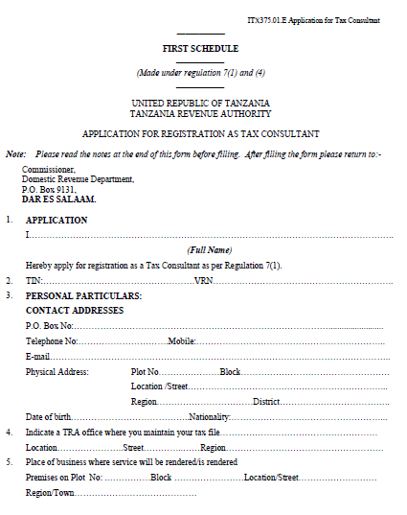
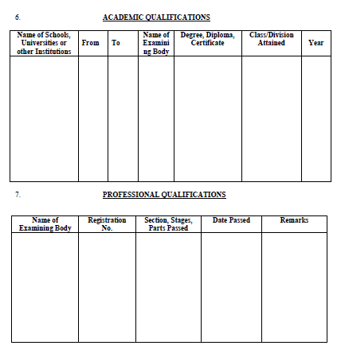
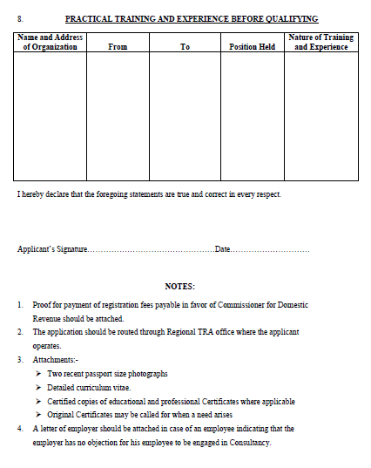
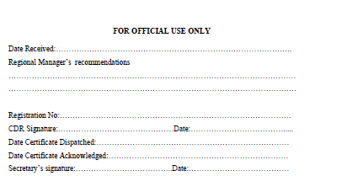
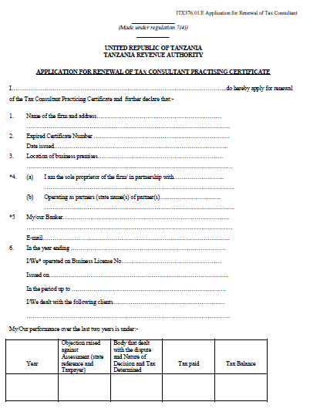

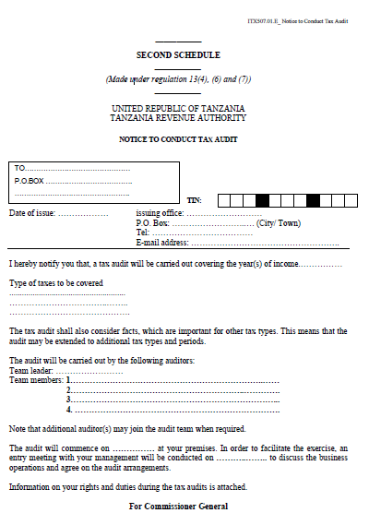
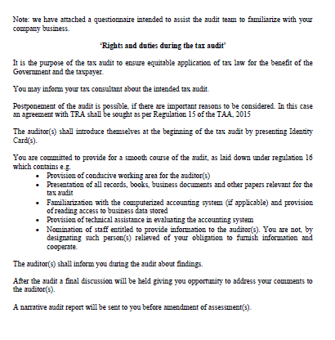

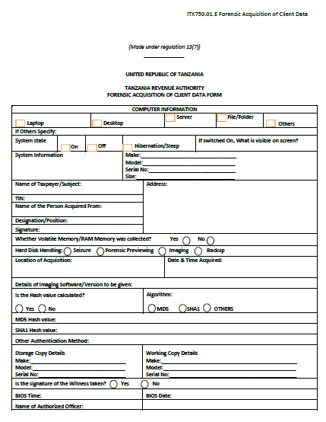
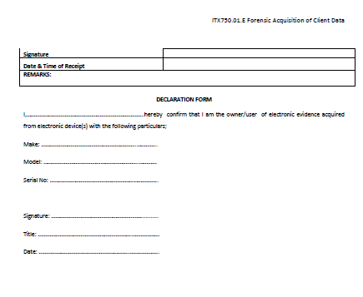

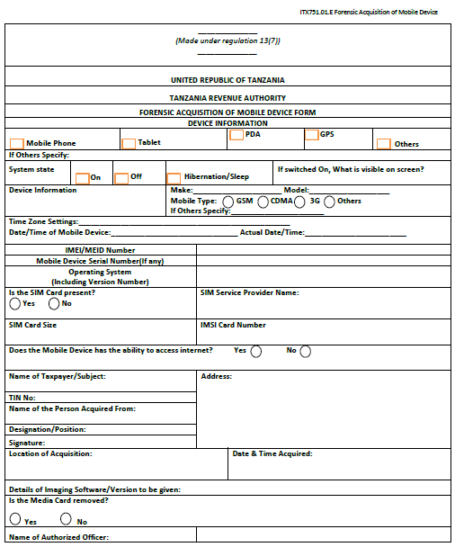

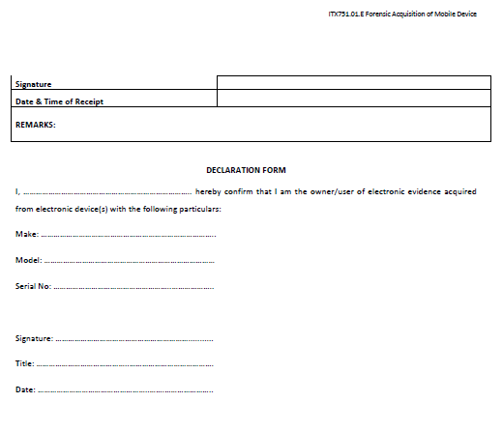

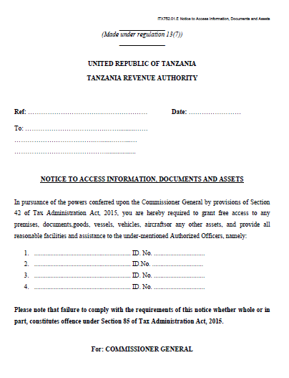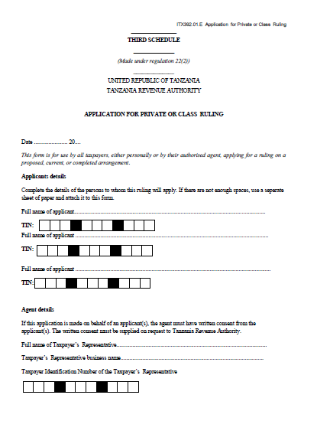
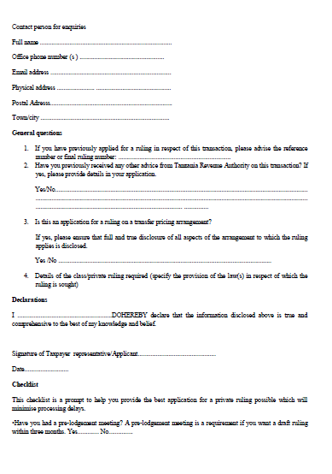
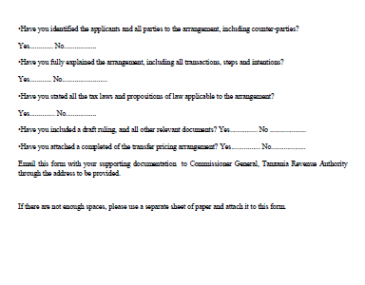
__________

FOURTH SCHEDULE
__________

(Made under regulation 31(1))
__________

CERTIFICATION ELECTRONIC FISCAL DEVICE SUPPLIERS APPROVAL PROCEDURE

For purpose of Suppliers Registration and Certification and EFD licensing, the following documentation and process shall be adopted before the machine is licensed and supplier is certified by the Commissioner General:
- detailed specification of the machines supplier plans to introduce in the market, in compliance with the specification described under these Regulations 2015;
- name of the manufacturers of the machines and brief history;
- certificate from the manufacturers or importers;
- names of countries where the machines have been successfully operating;
- brief explanation of security features for software and hardware;
- information on whether the EFD can securely interface with taxpayers systems in case a taxpayer is already using other machines and capable of transmitting information to TRA central database;
- brief back ground of supplier's business and experience in dealing with the machines;
- supplier's detailed training program for the operation and programming of the machines, the length of time required for the training and the training fees, if any;
- the technical, maintenance and repair service that the supplier will provide and the replacement parts supplier shall keep in their inventory;
- the amount of finance the supplier plans to allocate to the project;
- expected selling price for the machines;
- the guarantee supplier will provide in case of malfunction;
- supplier's bankers;
- list of qualified technical staff capable of performing periodic maintenance;
- any other relevant information the supplier's may wish to include in the business plan; and
- the proposal shall be accompanied with the following documents:
- operation and maintenance catalogues;
- photographs or block diagram;
- component lists;
- descriptive reports and security features write-up sample of all documents printed by the machine; and
- certificate of the safety for the electronic tax register or printer.

_________

FIFTH SCHEDULE
_________

(Made under regulation 34(2)(a))
__________

TECHNICAL SPECIFICATIONS OF ELECTRONIC FISCAL DEVICES

PART I
(GENERAL TECHNICAL REQUIREMENTS)
 | 1. The Electronic Fiscal Device shall have the following general technical features:
 | - language support: all information technologies shall provide support for English specifically, all display technologies and software must be ISO certified;
 | - dates: all information technologies shall properly display, calculate and transmit date data, including, but not restricted to 21st Century date data;
 | - electrical power: all active equipment shall have in-built power adapter or external power adapter to operate on: voltage range and frequency range of AC 220v +/- 20v, 50Hz - 60Hz to 6, or +24 all active equipment shall include power plugs in British standard;
 | - environmental: unless otherwise specified, all equipment shall operate in environments of temperature, humidity and dust conditions of, -10 to +60 degrees centigrade, 20-80 percent relative humidity and 0-40 grams per cubic meter of dust; and
 | - safely:
 | - unless otherwise specified, all equipment shall operate at noise levels no greater than 65 decibels; and
 | - all electronic equipment that emit electromagnetic energy shall be certified as meeting emission standard; US FCC class B or EN 55022 and EN 50082-1 or the equivalent.
PART II
HARDWARE SPECIFICATIONS
Physical features | 2. The Electronic Fiscal Device shall have the following physical features:
 | - a Fiscal Memory in-built in Raisin Epoxy that cannot be erased by mechanical, chemical or electromagnetic interference;
 | - a screw with a scalable top that can be sealed with lead or wax and sealed with a unique seal issued to the supplier. The machine shall not be able to be opened, unless the seal is broken and the screw removed;
 | - a port preferred USB and ETHERNET or RS 232 ports that can facilitate connection to the computer;
 | - display screen showing the inputs and output of the Electronic Fiscal Device to the user and customer as well;
 | - display screen capable of taking up to 13 digits inclusive of 2 decimal places;
 | - back-up battery which can go for at least 48 hours without external power supply or can use external battery in areas without electricity; and
 | - a real time clock.
Electronic Journal capabilities | 3. The Electronic Fiscal Device shall have the following Electronic Journal capabilities:
 | - Multi-Media Card Electronic Fiscal Journal or Signal Device Electronic Fiscal Journal that records all the transactions and other information that are printed on the Electronic Fiscal Device;
 | - first Signal Device Electronic Fiscal Journal shall activate the start of fiscalisation and hence begin recording the sales data and produce fiscal receipts without which a machine cannot function;
 | - the activated Electronic Fiscal Device shall send a message to the system for registration to enable it send the daily Z sales report. The message shall contain at least serial number, date and time of activation, and licence number of the Electronic Fiscal Device;
 | - the Electronic Journal Data shall neither be deleted nor reused;
 | - the Electronic Fiscal Journal shall not be reused when it is full;
 | - the Electronic Fiscal Devices shall record the data as from the date when the electronic journal was last updated and keep a record of all previous changes; and
 | - the Electronic Fiscal Journal can be moved to a card reader to allow viewing of the transactions details stored.
 | The data inside Electronic Fiscal Journal is automatic managed in a read-only.
Fiscal memory capabilities | 4. The Electronic Fiscal Device shall have the following fiscal memory capabilities. The fiscal memory shall record the following data:
 | - the date and time of commencing and ceasing of daily operations;
 | - the EFDs identification number. This is a unique number that identifies the user and the EFD itself;
 | - the tax rates assigned to the description of goods and services;
 | - the value of the sales without the tax, the value of sales exempted from tax divided into categories of individual tax rates, total amount of tax and total amount of the sales, including tax;
 | - the serial numbers and the dates for the resetting of the report every twenty four hours;
 | - the numbers and dates of resetting of the register memory and the information on the initiation of resetting and the methods of its performance;
 | - all amendments, corrections and cancellations;
 | - a minimum of 2,400 daily Z sales reports;
 | - reconnection reports each time the fiscal memory is disconnected; and
 | - the recorded data in the memory and record that data in the control paper roll electronic fiscal journal.
Printing capabilities | 5. The Electronic Fiscal Device shall have the following printing capabilities:
Printing capabilities | - print daily, monthly and annual reports;
 | - print the sales records from its memory as per standard time units (day, month, year);
 | - automatic self generation of daily Z reports every 24 hours;
 | - print on every receipt a TRA Logo with a non-standard font;
 | - print data recorded in the memory and by commands given through the keyboard;
 | - inserting the unique licence number of the Electronic Fiscal Device on each issued fiscal receipt;
 | - use of fiscal paper and ink with ultra violet TRA Logo made in a unique, non-standard form on the Electronic Fiscal Device in order to allow inspectors to identify genuine fiscal receipts;
 | - reprint a fiscal receipt or any other document in case of disconnection or paper jam;
 | - can easily replace paper rolls;
 | - equipped with sharp paper cutters;
 | - use either English or Kiswahili language.
Security and reliability | 6. The Electronic Fiscal Device shall have the following security and reliability:
Security and reliability | - password that will be uniquely used by users and the facility to change password. The minimum length of the password must be 6 digits;
 | - shall be registered on protected memory and not modified;
 | - shall be kept free from computer virus attack;
 | - has internal authentic data management;
 | - has intrinsic protection against unauthorised actions;
 | - has application upgrades that run independently without confronting security functions;
 | - can automatically save configured data and records on permanent memory;
 | - can automatically handle electronic journal memory of all sorts;
 | - has rechargeable internal batteries as well as power supplies;
 | - can print Z sales report before any configuration change;
 | - cannot allow update of stored data or reverse of transactions; and
 | - has unique serial number from the manufacturer allocated per country, in this case, a unique serial number that can only be used in Tanzania not elsewhere.
Connectivity | 7. The Electronic Fiscal Device shall have the following connectivity-
 | - internal GPRS modem that allows transmission of data upon every daily Z closure to TRA over GSM Network using SIM cards issued by approved GSM network provider by TRA and encrypted with a unique algorithm;
 | - all Z data shall be transmitted to and confirmation received from the system. The EFD shall be capable of re-transmitting the "Z" report in case a network failure occurs; and
- shall allow status queries to be made using the GPRS modem from the Commissioner General and be able to transmit requested information on transaction and statistics immediately upon request.
A detailed exhaustive description or the protocol shall be provided and secured with unique encrypted codes.
Programming capabilities | 8. The Electronic Fiscal Device shall have the following programming capabilities:
- allow programming of taxes with only 20 changes and header only 10 changes.
The changes shall be recorded on electronic fiscal memory;
 | - allow configuration in the Electronic Fiscal Device possible via a connected keypad and through a standard personal computer;
 | - allows programming of at least 6 different tax codes;
 | - allows date format for all printed documents to be in the form of DD-MM- YYYY:HHMMSS;
 | - shall not erase the programmed and recorded data when the internal battery of the machine becomes weak or discharged completely;
 | - shall allow direct printing or all recorded data on both fiscal memory and electronic journal from the Electronic Fiscal Device using a keypad device or viewing and printing from a standard personal computer by connecting the device using a personal computer interface such as USB, RS232 or Ethernet; and
 | - shall not reverse the Electronic Fiscal Device dates and time less than last transactional date.
Devices compliance | 9. The Electronic Fiscal Device shall have the following device compliance:
Devices compliance | - approved by international recognised bodies, and evidence shall be provided to the Commissioner General for the accreditation of such bodies prior to approving the use of such devices in Mainland Tanzania;
- certified as relevant device for performance of work intended.
A certificate with full annexes of all tests performed on the Electronic Fiscal Device and results thereon shall be submitted to the Commissioner General for approval; and
 | - supplied with its manual, software, accessories and all necessary documentations.
PART III
FISCAL MANAGEMENT SOFTWARE
Fiscal management software | 10.-(1) Fiscal management software is intended to run on the Electronic Fiscal Device system that shall be used to receive all transactions or Z-reports from all Electronic Fiscal Devices and generate various required reports.  The software shall as minimum have the following features:
 | - architecture requirement shall be able to run in 64x bits servers;
 | - operating System Platform Requirement:
 | - shall be able to run in either Linux or Windows platform;
 | - shall be a web based, application to enable Commissioner General’s officers access central server remotely;
 | - database requirement shall be able to connect on the oracle 10g database;
 | - interface requirement shall be able to interface with the system running on the above mentioned platforms and database;
 | - security requirement shall have user management console and authenticate Commissioner General officers on login;
 | - operational requirements:
 | - the software shall be capable of browsing and connecting to an electronic journal of any fiscal device in the network and retrieve in a read-only mode the transactions entered;
 | - shall allow the Commissioner General’s officers to change tax rates to all Electronic Fiscal Devices centrally as required by the tax laws; and
 | - shall allow Commissioner General’s officers to produce customised reports; and
 | - operational reports.
 | (2) The fiscal software shall allow Commissioner General’s officers to produce the user defined reports as follows:
 | - architecture requirement: shall be able to run in 64x bits servers;
 | - operating system platform requirement:
 | - shall be able to run in either Linux or Windows platform; and
 | - shall be a web based application to enable Commissioner General's officers access central server remotely.
 | - database requirement: shall be able to connect on the oracle 109 database;
 | - interface requirement: shall be able to interface with the system running on the above mentioned platforms and database;
 | - security requirement: shall have user management console and authenticate Commissioner General’s officers on login; and
 | - operational requirements: the software shall be capable of:
 | - browsing and connecting to an electronic journal of any Electronic Fiscal Devices in the network and retrieve in a read-only mode the transactions entered;
 | - shall allow the Commissioner General's officers to change tax rates to all Electronic Fiscal Devices centrally as required by the tax laws;
 | - send a confirmation message to newly activated devices to enable them send daily Z report; and
 | - allowing Commissioner General's officers to produce customised reports.
Operational reports | 11.-(1) The fiscal software shall allow Commissioner General's officers to produce the user defined reports described as follows:
 | - daily gross sales: the daily report shall contain the following for any given trader:
 | - serial number of the transaction;
 | - location of the taxpayer;
 | - user Identification Number of the Electronic Fiscal Device;
 | - Taxpayer Identification Number (TIN) of the customer;
 | - VAT Registration Number VRN), if any;
 | - discounts, if any;
 | - net value;
 | - VAT rate;
 | - VAT amount; and
 | - total gross sales and cumulative totals by distinguishing between taxable, exempt and zero rated.
 | (2) The system shall allow the user to filter the daily report according to taxable, exempt, zero rated sales or any required label.
Weekly gross sales | 12. The weekly gross sales shall contain daily gross sales (Z daily transaction records).
Monthly gross sales | 13. Monthly gross sales shall contain daily gross sales (Z daily transaction records) with weekly subtotals.
Annual gross sales | 14. The annual gross sales shall contain daily gross sales (Z daily transaction records) with monthly subtotals.
Number of Electronic Fiscal Device interruptions | 15.-(1) The Electronic Fiscal Devices interruption report shall contain the following information:
Number of Electronic Fiscal Device interruptions | - serial numbers of Electronic Fiscal Devices interventions;
Number of Electronic Fiscal Device interruptions | - number of intervations;
 | - licence number of the machine intervened;
 | - serial number of the machine disconnected;
 | - number of disconnections;
 | - number of electronic journal replacement;
 | - date and time;
 | - type of errors and number of errors; and
 | - receipts or invoices in which errors occurred; the report shall be able to distinguish between disconnections, errors, change of name and interventions to the device.
 | (2) The system shall allow the user to filter report according to taxable, exempt, zero rated sales or any required label.
Daily, monthly and annual comparable report by sector and location | 16. Number of receipts or invoices issued, sales made in terms of taxable, zero rated and exempt supplies.
Daily, monthly and annual comparable report by products or items | 17. Daily, monthly and annual comparable report by products or items shall contain:
 | - number of receipts or invoices issued, sales made in terms of taxable, zero rated and exempt supplies; and
 | - the comparable report by sector, location, and item or product as referred in appendix Ill, IV and V respectively, shall distinguish between taxable, exempt and zero rated supplies and shall contain the following information-
 | - date or period selected for comparison;
 | - number of receipt or invoice issued;
 | - sales made; and
 | - total and cumulative totals.
Comparison between amounts declared in vat monthly return against sales | 18. The comparison report between the amount declared in VAT monthly return and Electronic Fiscal Devices sales as referred in appendix IV shall contain the following information:
 | - sales as per VAT return (taxable, exempt and zero rated);
 | - sales as per Electronic Fiscal Device (taxable, exempt and zero rated); and
 | - variance (taxable, exempt and zero rated).

________

SIXTH SCHEDULE
_________

(Made under regulation 37(1)(b))
_________

PART I
REQUIRED RECORDS AND INFORMATION TO BE GENERATED
BY ELECTTRONIC FISCAL DEVICE
Fiscal Electronic Fiscal Device receipt | 1. The fiscal receipts generated by Electronic Fiscal Device shall have the following contents:
Fiscal Electronic Fiscal Device receipt | - the words: "START OF LEGAL RECEIPT" at the top and "END OF LEGAL RECEIPT" at the bottom;
 | - the name and address of the user of the registered Electronic Fiscal Device;
 | - the VAT registration number of the user of the Electronic Fiscal Device;
 | - Taxpayer Identification Number (TIN) of the user of the registered Electronic Fiscal Device;
 | - name and address of the purchaser;
 | - the VAT registration number and TIN of the purchaser;
 | - the identification number of the device;
 | - the name, quantity, unit price, item description, tax rate chargeable on and the value of the recorded sale of goods or services;
 | - the tax amount payable;
 | - discounts, mark-ups, changes and corrections;
 | - the date and time of issue of the receipt;
 | - the total amount payable, tax inclusive;
 | - daily ascending serial number for a Legal Electronic Fiscal Device Receipt; and
 | - the fiscal logo.
Electronic Fiscal Device Invoice | 2. The fiscal invoice generated by Electronic Fiscal Device shall have the following contents:
Electronic Fiscal Device Invoice | - the name and address of the user of the registered Electronic Fiscal Device;
Electronic Fiscal Device Invoice | - the VAT registration number of the user of the device;
 | - Taxpayer Identification number (TIN) of the user of the registered Electronic Fiscal Device;
 | - name and address of the purchaser;
 | - the VAT registration number and TIN of the purchaser;
 | - the identification number of the Electronic Fiscal Device;
 | - the name, quantity, unit price, item description, tax rate chargeable on and the value of the recorded sale of goods or services;
 | - the tax amount payable;
 | - discounts, mark-ups, changes and corrections;
 | - the date and time of issue of the invoice;
 | - the total amount payable, tax inclusive;
 | - daily ascending serial number for a Legal Fiscal Device Invoice; and
 | - the fiscal invoice bears electronic signature beneath after the end of the business transactions.
Daily report | 3.-(1) The Electronic Fiscal Device shall generate "Z" daily transaction report, even where no daily transaction has taken place and the daily running totals in the working memory give zero.
 | (2) The information printed on the "Z" report shall be contained between the phrase "START OF LEGAL RECEIPT and "END OF LEGAL RECEIPT".
 | (3) The information to be contained in a daily report ("Z" Daily transaction record) from Electronic Fiscal Device shall be as follows:
 | - name or trading name and address of the business;
 | - taxable goods or services;
 | - VAT Registration Number (VRN) and Taxpayer Identification Number (TIN);
 | - tax offices which assess the taxpayer or users of the approved Electronic Fiscal Device;
 | - heading "Z" daily transaction report;
 | - the serial number of the Z daily transaction report;
 | - the identification number of the approved Electronic Fiscal Device, where there is more than one approved Electronic Fiscal Device in the same out let;
 | - the time and date the “Z” daily transaction report was generated;
 | - the daily running and cumulative totals, such as:
 | - taxable supplies;
 | - total gross sales;
 | - total gross sales, if any; and
 | - any reports from the tax data memory since the previous (last) "Z" daily transaction report was generated stating:
 | - the number of revenue receipts generated for the day;
 | - changes in VAT prices (in details from .... to ….);
 | - discounts, mark ups, changes and corrections;
 | - number of working memory errors, name changes (in details from ....to ...);
 | - number of printer disconnections; and
 | - number of interventions by authorised engineer or technician.
 | - the reports from the data memory from when the approved Electronic Fiscal Device was registered, including the current tax daily transaction, stating:
 | - the running VAT totals (one for each VAT rate);
 | - the total gross supplies the Electronic Fiscal Device was commissioned; and
 | - distinguishing between zero-rated, taxable and exempt supplies.
 | - number of revenue receipts generated;
 | - total number of VAT rate charges;
 | - total number of working memory errors;
 | - total number of name changes;
 | - total number of spontaneous printer disconnections;
 | - number of intervention; and
 | - the licence number of the approved Electronic Fiscal Device.
Monthly report | 4.-(1) The approved Electronic Fiscal Device shall be capable of reading and printing the content of the data memory at all times by selecting any calendar period (from ..... to .... ) or by selecting two different "Z" daily transaction record numbers (the first and the last).
 | (2) The information to be found in a monthly report shall include the:
 | - name or trading name and address of the business;
Cap.332 | - taxable goods or services in respect of VAT and goods or services in respect of Income Tax Act;
 | - VAT Registration Number (VRN) and Taxpayer Identification Number (TIN);
 | - tax offices which assess the taxpayer or users of the approved Electronic Fiscal Device;
 | - heading "Z" Monthly report;
 | - identification number of Commissioner General's approved Electronic Fiscal Device, where there are more than one approved Electronic Fiscal Device in the same out let;
 | - time and date the "Z" daily transaction report was generated;
 | - for each "Z:" daily transaction record shall contain the:
 | - serial number of the "Z" daily transaction report and the date it was generated;
 | - amounts in VAT for the day covered by the daily transaction report in question (one for each rate);
 | - total gross sales covered by the "Z" daily transaction report in question, distinguishing between zero-rated, taxable and exempt supplies;
 | - number of revenue receipts generated for the day covered by the "Z" daily transaction report in question;
 | - number of VAT rate changes for the day covered by the "Z" daily transaction report in question;
 | - number of working memory errors for the day covered by the “Z” daily transaction report in question;
 | - number of name changes for the day covered by the "Z" daily transaction report in question;
 | - number of spontaneous printer disconnections for the day covered by the "Z" daily transaction report in question; and
 | - number of interventions by an authorised engineer or technician;
 | - approved Electronic Fiscal Device tax data memory reports for the period in question, stating:
 | - the running VAT totals (one for each VAT rate);
 | - total gross sales distinguishing between zero-rated, taxable and exempt supplies;
 | - total number of VAT rate changes;
 | - total number of working memory errors;
 | - total number of name changes;
 | - total number of spontaneous printer disconnections;
 | - total number of interventions by authorised engineer or technician; and
 | - the registration number of the Commissioner General approved Electronic Fiscal Device.
Annual report | 5.-(1) The approved Electronic Fiscal Device must be possible to read and print a summary report of the content of the tax data memory at all times by selecting any calendar period (from ... to ... ) or by selecting two different "Z" daily transaction report numbers (the first and the last).
 | (2) The annual report shall contain the following the:
 | - name or trading name and address of the business;
 | - taxable goods or services for VAT;
 | - VAT Identification Number and Taxpayer Identification Number;
 | - Electronic Fiscal Device;
 | - heading "Annual Report";
 | - identification number of the approved Electronic Fiscal Device, where there is more than one approved Electronic Fiscal Device in the same out let;
 | - time and date the "Z" daily transaction report was generated;
 | - approved Electronic Fiscal Device tax data memory reports for the period in question, stating the:
 | - running VAT totals (one for each VAT rate);
 | - total gross revenue distinguishing between zero-rated;
 | - taxable and exempt supplies;
 | - number of revenue receipts generated;
 | - total number of VAT changes;
 | - total number of working memory errors;
 | - total number of name changes;
 | - total number of spontaneous printer disconnections; and
 | - total number of "interventions" by authorised engineer or technician; and
 | - registration number of the Electronic Fiscal Device.
PART II
OPERATIONAL REPORTS
Reports | 6. The following reports shall be generated by the system from the Tanzania Revenue Authority database.
Daily gross sales | 7.-(1) The daily report shall contain the following information for any given trader the:
 | - serial number of the transaction;
 | - location of the taxpayer;
 | - licence number of the Electronic Fiscal Device;
 | - Taxpayer Identification Number (TIN) of the customer;
 | - VAT Registration Number (VRN), if any;
 | - receipt or invoice number;
 | - items sold;
 | - quantity;
 | - unit price;
 | - values;
 | - date of the transaction;
 | - discounts, if any;
 | - net value;
 | - VAT rate;
 | - VAT amount;
 | - total gross sales and cumulative totals by distinguishing between taxable, exempt and zero rated; and
 | - sales made in respect of Income Tax.
 | (2) The system shall allow the user to filter report according to taxable, exempt or zero rated sales or any required label.
Weekly gross sales | 8. The weekly gross sales shall contain daily gross sales (Z daily transaction records).
Monthly gross sales | 9. Monthly gross sales shall contain daily gross sales (Z daily transaction records) with weekly subtotals.
Annual gross sales | 10. The annual gross sales shall contain daily gross sales (Z daily transaction records) with monthly subtotals.
Number of Electronic Fiscal Device interruptions | 11.-(1) The Electronic Fiscal Device interruption report shall contain the following information the:
Number of Electronic Fiscal Device interruptions | - serial numbers of Electronic Fiscal Device interventions;
Number of Electronic Fiscal Device interruptions | - number of interventions;
 | - licence number of the Electronic Fiscal Device intervened;
 | - serial number of the machine disconnected;
 | - number of disconnections;
 | - number of electronic journal replacement;
 | - date and time;
 | - type of errors and number of errors; and
 | - receipts or invoices in which errors occurred.
 | (2) The report shall be able to distinguish between disconnections, errors, change of name and interventions to the device.
 | (3) The system shall allow user to filter report according to taxable, exempt or zero rated sales or any required label.
 | (4) The sample format of the report shall be as indicated in Appendix 5.
Daily, monthly and annual comparable report by sector, location and products or items | 12.-(1) Daily, monthly and annual comparable report by sector shall contain the:
 | - number of receipts or invoices issued; and
 | - sales made in terms of taxable, zero rated and exempt supplies.
 | (2) Daily, monthly and annual comparable report by location shall contain the:
 | - number of receipts invoices issued;
 | - sales made in terms of taxable, zero rated and exempt supplies; and
 | - sales made in respect of income tax.
 | (3) Daily, monthly and annual comparable report by products or items shall contain the:
 | - number of receipts or invoices issued; and
 | - sales made in terms of taxable, zero rated and exempt supplies.
 | (4) Total gross supplies the Electronic Fiscal Device was commissioned, distinguishing between:
 | - taxable;
 | - exempt;
 | - zero rated supplies; and
 | - sales made in respect of income tax.
 | (5) The comparable report by sector, location and item or product shall contain the following information the:
 | - date or period selected for comparison;
 | - number of receipt or invoice issued;
 | - sales made (taxable, exempt or zero rated); and
 | - total and cumulative totals.
Comparison between amount declared in VAT monthly return against sales or amount of income tax declared against sales | 13. The comparison report between the amount declared in VAT monthly return and Electronic Fiscal Device sales shall contain the following information:
 | - sales as per VAT return (taxable, exempt and zero rated);
 | - sale as per Electronic Fiscal Device (taxable, exempt and zero rated); and
 | - variance (taxable, exempt and zero rated).

_________

SEVENTH SCHEDULE
_________

(Made under regulation 54(2))
_________

COST FOR AQUISITION OF ELECTRONIC FISCIAL DEVICIES

 | 1. The costs incurred by a user for the acquisition of an Electronic Fiscal Device from an approved supplier for the first time shall be borne by the Government.
 | 2. The cost incurred by taxable person shall be deducted as input tax in the VAT return.
Cap.332 | 3.-(1) In the case of a non taxable person the cost shall be treated as an expenditure deductible under section 11(2) of the Income Tax Act.
 | (2) In the case of a presumptive taxpayer the cost shall be deducted from tax payable, in the year of income in which the Electronic Fiscal Device is acquired and if not fully deducted, in subsequent year of income.

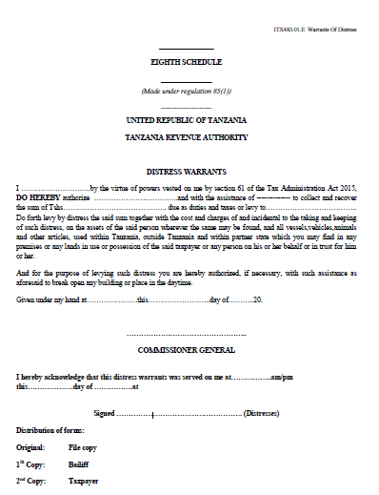
_______
NINETH SCHEDULE
_______

(Made under regulation 90(1))
_______

DISTRAINT AGENTS FEES

PART I
ATTACHMENT OF CHARGED ASSETS
 | 1. For attaching or taking possession of a charged asset and keeping possession of the same for thirty days or part, when the sale value or, if the asset is not sold, the distraint officer’s estimated value of the same:
 |  | Value | Fees
 |  | does not exceed Shs. 200,000/= | 5%
 |  | exceeds Shs. 200,000/= but does not exceed Shs. 2,000,000/= | 3%
 |  | exceeds Shs. 2,000,000/=but does not exceed Shs. 50,000,000/= million | 3%3%
 |  | exceeds Shs. 50 million | 1%
 | Provided that, where it is considered necessary to hold the asset for a longer period the distraint agent shall, in addition to the fee calculated on the basis of this paragraph, be reimbursed for the additional costs and expenses which, in the opinion of the Commissioner General, are property incurred.
 | 2. When intending to attach or take possession of a charged asset where no property is found, the distraint agent shall be reimbursed for actual expenses incurred in the exercise.
PART II
SALE
 | 3. For selling a charged asset where the amount realised:
 |  | Value | Fees
 |  | does not exceed Shs. 200,000/= | 5%
 |  | exceeds Shs. 200,000/= but does not exceed Shs. 2,000,000/= | 3%
 |  | exceeds Shs. 2,000,000/=but does not exceed Shs. 50,000,000/= | 3%
 |  | exceeds Shs. 50,000,000/= 1 million | 1%
 | 4. Where an order of sale has been made out but the distraint agent is informed by the Commissioner General that the charge over the asset has been released, the order for sale has been set aside, the sale is postponed or the asset is for any other reason unsold or where the distress amount and costs (including costs of charge and sale) are tendered to the distraint agent or proof is given to his satisfaction that such amount and costs have been paid:
 |  | Value | Fees
 |  | before commencement of sale | No fees, except under Part I
 |  | after commencement of the sale process, where the distraint officer’s estimated value of the asset ordered to be sold-
 |  | - does not exceed Shs. 200,000/= | 3%
 |  | - exceeds Shs. 200,000/= but does not exceed Shs. 2,000,000/= | 2%
 |  | - exceeds Shs. 2,000,000/= but does not exceed Shs. 50,000,000/= | 1.5%
 |  | - exceeds Shs. 50,000,000/= | 1%
 | 5. Where the charged asset is divided into lots for the purpose of being sold separately and any lot is unsold because no bid has been received for it or no bid equal to the reserve price, as the case may be, the fees prescribed in respect of sold lots shall be the fees applicable for the sold lots only.
 | 6. Where the charged asset or part of it is sold, the distraint agent shall be paid reasonable expenses incurred by him in transporting the asset and such travelling expenses by car or a rateable proportion as the Commissioner General may approve.

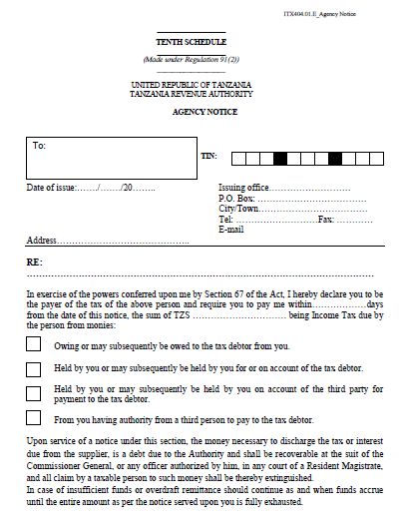
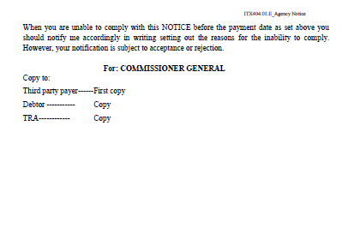
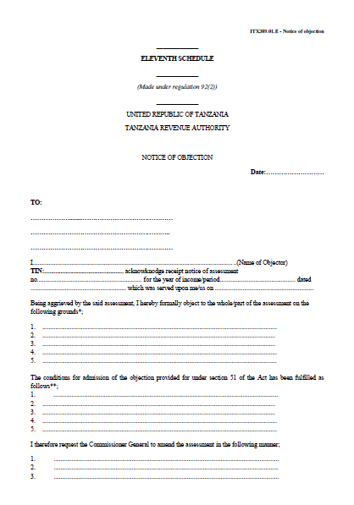
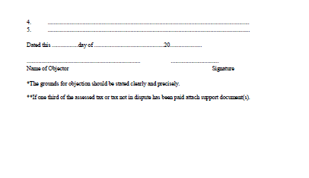
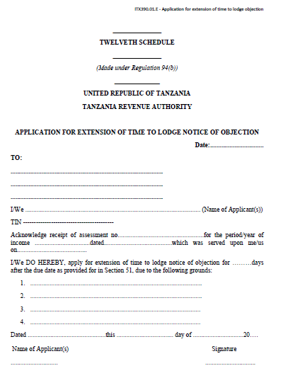
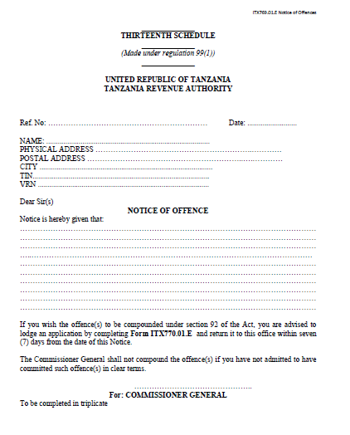
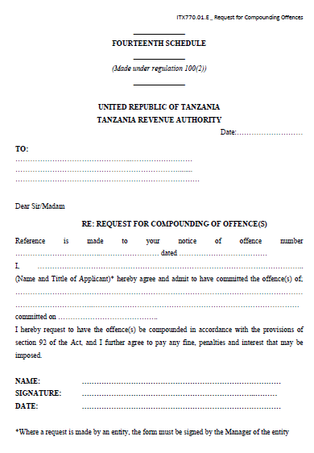
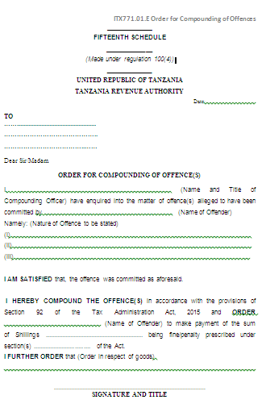

ITX421.01.E_ Tax Clearance Certificate
________

SIXTEENTH SCHEDULE
_________

FORMS
__________

(Made under regulation 103(2))
__________

UNITED REPUBLIC OF TANZANIA
TANZANIA REVENUE AUTHORITY

TAX CLEARANCE CERTIFICATE
Tax Clearance Certificate Number

Issuing office:
Telephone:
Approved Date:
Expiry Date
To

Taxpayer Name
Trading Name
Taxpayer Identification Number (TIN)
Company Registration Number
VAT Registration Number
This is to certify that the above registered Taxpayer has complied with the tax laws and has been granted Tax Clearance Certificate with respect to the following business(es):
………………………………………………………………………………………………………………………………………………………………………………………………………………………………………………………………

This Certificate should be tendered in its original form and is valid only if it is embossed with the Official Seal.

………………………………………………………………………………….
COMMISSIONER FOR DOMESTIC REVENUE

Date: …………………………………………………

Official Seal
Disclaimer: This Tax Clearance Certificate shall not preclude the Commissioner General from demanding and recovering taxes established after issuance of this Certificate.

THIS CERTIFICATE IS ISSUED FREE OF CHARGE

Dar es Salaam, Philip I. Mpango,
4th March, 2016 Minister for Finance and Planning

